**CHAPTER-4**

**APPLICATION OF ANN IN FORMULATION DEVELOPMENT OF CLOPIDOGREL BISULPHATE COMPLEXES & DOLUTEGRAVIR SODIUM COMPLEXES**

**4.1. INTRODUCTION TO ARTIFICIAL NEURAL NETWORKS**

The ability of neural networks to emulate the brain’s ability to learn by example has gained a lot of attention among scientists globally, being one of the greatest computational tools ever developed; this network makes decision and draws conclusions even when presented with incomplete information. It is a very good tool for many numeric as well as non-numeric calculations and is applied to numerous problems of considerable complexity in many fields, including engineering, psychology, medicinal chemistry, diagnostics, and pharmaceutical research1. ANN is a parallel, distributed information processing structure consisting of processing elements interconnected via unidirectional signal channels called connections. In simple words, they are computer systems developed to mimic the operations of the human brain by mathematically modelling its neurophysiologic structure and function2. ANN is capable of simulating neurological processing ability of the human brain. Average human brain contains about 100 billions of neurons with each neuron being connected with 1000-10,000 connections to others. During the development of pharmaceutical dosage forms, finding an optimal composition of inclusion complexes can be a difficult task, since both proportion of each component of the carrier mixture and proportion of drug can significantly affect the complexation properties. Most of the previous studies were conducted with a few different compositions of carrier mixtures or different drug: carrier ratios, wherein simultaneous variation of the proportions of all CDs components has been rarely investigated. The prediction of pharmaceutical responses based on ANN is widely accepted. In this study, ANNs were used as a machine learning technique to evaluate the influence of cyclodextrins (β-CD, HP-β-CD) on dissolution enhancement of CBS and DTG with and without hydrophilic polymers (PVP K30, PEG 6000 & SOLUPLUS). This chapter mainly focuses on the optimisation and prediction of the best output in formulation development. The values of the drug and polymer concentrations are given as inputs. Values of percent drug released at different time points would be used to train the ANN. The ANN would predict the expected percent release at each sampling time point (based on its learning of the total behaviour of the system and using computational modelling) and that would be the output. That formulation, for which the difference between the observed percent release and the expected percent drug release given as output by the ANN is the least among all such values, would be the best formulation or the optimised product. A trained ANN model was employed to predict the release profile and optimize the formulation composition based on the percentage of the drug released.

**4.1.1. STRUCTURE OF BIOLOGICAL AND ARTIFICIAL NEURONS**

This section details the structures of biological and artificial neurons and correlates their functions.

**4.1.1.1. Biological neuron structure**

Each biological neuron has three principal components, namely, dendrites, cell body and axon as shown in **Figure 4.1.1.1**.**1**. The dendrites are tree-like receptive networks of nerve fibres that carry electrical signals into the cell body. The cell body effectively sums and thresholds these incoming signals. The axon is a single long fibre that carries the signal from the cell body out to other neurons. The point of contact between an axon of one cell and a dendrite of another cell is called a synapse. A neuron is connected to other neurons through about 10,000 synapses (**Figure 4.1.1.1.2**).

A neuron receives input from other neurons and then all inputs are combined. Once input exceeds a critical level, the neuron discharges a spike ‐ an electrical pulse that travels from the body, down the axon, to the next neuron(s). The axon endings almost touch the dendrites or cell body of the next neuron. Transmission of an electrical signal from one neuron to the next is effected by neurotransmitters. Neurotransmitters are chemicals which are released from the first neuron and which bind to the second. This link is called a synapse. The strength of the signal that reaches the next neuron depends on factors such as the amount of neurotransmitter available.

It is the arrangement of neurons and the strengths of the individual synapses, determined by a complex chemical process that establishes the function of the neural network.

Axon from another cell

Axon

Synapse

Nucleusss

Synapses

Cell Body or soma

Dendrite

**Dendrites**: Input

**Cell body**: Processor

**Synaptic**: Link

**Axon**: Output

**Figure 4.1.1.1.1: Structure of Biological neuron**

Neural structures continue to change throughout life. These later changes tend to consist mainly of strengthening or weakening of synaptic junctions. New memories are formed by modification of these synaptic strengths. Thus, neurons have the capability to memorize, learn and expertise the data.

Axon

Cell Body

Basal dendrites

Segment of dendrite

Synaptic inputs

Dendritic spines

Apical dendrites

Synaptic terminals

**Figure 4.1.1.1.2: Biological neuron connection to other neurons**

**4.1.1.2. Artificial neuron structure**

Each artificial neuron within the artificial neural network is usually an information processing unit which takes one or more inputs and produces an output (**Figure 4.1.1.2.1**). At each neuron, every input has an associated weight which modifies the strength of each input. The neuron simply adds together all the inputs and calculates the output to be passed on.

x1

x2

x3

x4

x5

w1

w2

w3

w4

w5

Output is fed to other neurons

Inputs

**Figure 4.1.1.2.1: Model of artificial neuron**

**Analogy between biological and artificial neurons:**

An artificial neuron is an imitation of a human neuron. In ANN, the weight corresponds to the strength of a synapse, the cell body is represented by the summation and the transfer function, and the neuron output represents the signal on the axon. **Figure 4.1.1.2.3** shows the simplified schematic diagram of analogy between biological neuron and artificial neuron.

The model of the neuron which forms the basis of the design of artificial neural network has

1. A set of synapses or connecting links, each of which is characterized by weight or strength of its own (xj × wj). Specifically, a signal xj at the input synapse j, connected to the neuron k, is multiplied by the weight, wj.
2. an adder for summing the input signals, weighted by respective synapses of the neuron, the operation described here constitutes a linear combiner (∑xiwi = x0w0+x1w1 + ….+xnwn = output)
3. An activation function for limiting the amplitude of output of the neuron (**Figure 4.1.1.2.3**).

**Artificial Neuron**

Y0=W0X0

Y1=W1X1

......

YN=WNXN

W0

W1

......

WN

X0

X1

......

XN

Output

Weights

Processing Element

Activation Function

Interconnects

Soma

Axon

Dendrites

Conduction

**Biological Neuron**

**Figure 4.1.1.2.3: Biological Neuron and its equivalent artificial neuron**

**Input and output of a neuron**

The variables applied to a neuron are called its inputs and the output of the neuron is its value. The graphical representation of a simple basic neuron is shown in **Figure 4.1.1.2.4**. The neuron’s output (y) is a nonlinear combination of the inputs, {xi}. These inputs are weighed by the parameters, {wji}, often termed weights, or synaptic weights. The neuron’s output can be written as

y = *f*(x1, x2... xi; vj; wj1, wj2, . . . ,wji)

Function [*f*(.)] is the activation function and vj is termed as the bias input. The bias vj, which a neuron has, is summed with the weighted inputs to form the net input. The function [*f* (.)] that is performed by neurons depends on the weight vector on the neurons. The weight vectors are usually determined in so called “training phase” using a learning algorithm. These weights determine the output of the neural network; therefore, it can be said that the connection weights form the memory of the neural network. **Figure 4.1.1.2.4** shows the details of the elementary neuron structure with input as *xi*. Each input is weighted with an appropriate weight wji. The sum of the weighted inputs and the bias, vj forms the input to the transfer function [*f*(.)]. Neurons can use any differentiable transfer function, [*f*(.)] to generate their output and is given by

Output = f( input 1 × weight 1 + input 2 × weight 2 + ... ) = 

**:**

**:**

x 1

bias vj

x 2

x i

xn

wji

wj2

f (.) transfer function

jth neuron output  **y**

wj1

**Figure 4.1.1.2.4:** Inputs and output of neurons

In mathematical terms, ANN is defined as a directed diagram with the following properties:

1. An input vector xj associated with each node j (referred as neuron j)
2. A real valued weight wji is associated with a link (referred as synapses) between two nodes j and i.
3. A real valued bias (referred as activation threshold) vj is associated with each node j
4. A transfer function *f*j [xi, wji, vj, ( i ≠ j)] is defined for each node j, which determines the state of the node as function of its bias, the weights of its incoming links and the states of the nodes connected to it by these links.

Nodes without links towards them are called input neurons and the output neurons are those without a link leading away from them. A feed forward network is one whose topology has no closed paths. The transfer function takes the form as given below.

 (4.1)

Where, f (z) is either a discontinuous step function or smoothly increasing generalization known as a sigmoidal function.

**4.1.2. ANN MODELLING**

Alike the brain, ANN is composed of numerous processing units, artificial neurons. The connections among all the units vary in strength, which is defined by coefficients or weights. The ANN mimics working of human brain and potentially fulfils the cherished dream of scientists to develop machines that can think like human beings. ANNs simulate learning and generalization behaviour of the human brain through data modelling and pattern recognition for complex multidimensional problems. A significant difference between an ANN model and a statistical model is that the ANN can generalize the relationship between independent and dependent variables without a specific mathematical function. Thus, an ANN works well for solving nonlinear problems of multivariant and multiresponse systems such as space analysis in quantitative structure-activity relationships in pharmacokinetic studies3 and structure prediction in drug development4.

Three simple steps involved in neural networking are—

1. Network design
2. Learning or training
3. Usage or testing phase.

In the network design, stage the number of connections and layers is selected based on the type of application. Then, the training stage requires selection of training set of data and remodelling of the network to minimize the error. And lastly, following the training ANN is suitable to use network design. Number of hidden layers is essential to the purpose and function of an ANN as it influences the number of connections in the network and, thus, its performance. **Figure 4.1.2.1** illustrates the 2 layer ANN architecture with 11 input nodes (inputs), 1 hidden layer with 4 nodes and 1 output layer with 2 nodes.

Input layer

with 11 nodes

Hidden layer with 4 nodes

Output layer with 2 nodes

node 1

node 2

node 10

node 11

Weighted

connection

Neuron

Input vector

Output

**Figure 4.1.2.1: A two layer ANN formation**

**4.1.3. APPLICATIONS OF ANN IN PHARMACEUTICAL PRODUCT FORMULATIONS**

Various examples of applications of ANN in pharmaceutical product formulations globally are shown in **Table 4.1.3.**

**Table 4.1.3.1: Examples of applications of ANN in pharmaceutical product formulations**

|  |  |  |
| --- | --- | --- |
| **S.NO** | **ANN APPLICATION EXAMPLES** | **Ref. No.** |
|  | **IN IMMEDIATE RELEASE ORAL FORMULATIONS** |  |
| 1. | Direct compression tablet formulation of hydrochlorothiazide using ANN in order to maximize tablet strength and select the best lubricant | 5 |
| 2. | Application of ANN tablet formulation of caffeine in order to relate both formulation (diluent type and concentration, binder concentration) and processing variables (type of granulator, method of addition of binder) with granule and tablet properties (friability, hardness, and disintegration time). | 6 |
| 3. | Optimization of crushing strength and disintegration time of a high-dose plant extract tablet using ANN. | 7 |
| 4. | Prediction of drug content and hardness of intact tablets of theophylline mixed with microcrystalline cellulose from their near-infrared spectra using neural networks. | 8 |
| 5. | Application of ANN for predicting the dissolution of 28 diltiazem immediate release tablet formulations. | 9 |
|  | **IN CONTROLLED RELEASE ORAL FORMULATIONS** |  |
| 1. | Optimization of diclofenac sodium sustained release matrix tablets using ANN, where different formulation variables like concentrations of cetyl alcohol, PVP K30 and magnesium stearate, and sampling time were chosen as inputs. | 10 |
| 2. | Application of ANN model in optimization of controlled release theophylline tablets prepared with controse, mixture of HPMC with lactose and cornstarch. | 11 |
| 3. | A generalized regression neural network (GRNN) was used in the design of extended-release aspirin tablets using eudragit RS PO compression pressure as casual factors. | 12,13 |
| 4. | Use of neural networks in the formulation of salbutamol sulfate osmotic pump tablets, using different amounts of HPMC and PEG present in the cellulose acetate coating, in addition to the coating weight, as control factors and predicting the release parameters for 1000 formulations; from which they selected an optimised formulation with the desired release pattern. | 14 |
| 5. | Application of both multi-layer perceptrons and recurrent neural networks to modelling the release of theophylline from a matrix controlled release pellet formulation prepared using extrusion and spheronization. | 15,16 |
| 6. | Comparison of response surface methodology and neural networks for modelling and optimizing the effect of the process and formulation variables on the release profile of verapamil hydrochloride. | 17 |
| 7. | Compression of fluidized bed manufactured, enteric-coated, omeprazole pellets into tablets using neural networks where tablet strength and the concentration of the microcrystalline cellulose are used as a compression aid. | 18 |

**ANN MODELLING ADVANTAGES AND DISADVANTAGES:**

**Advantages**

* Effective use of incomplete data sets
* Rapid analysis of data
* Ability to accommodate more data and retrain the network
* Effective exploration of the total design space, irrespective of complexity
* Ability to accommodate constraints and preferences and
* Ability to generate understandable rules2, 12, 13.

**Disadvantages**

* Problems related to software and lack of development skills
* A number of features should be present before neural computing
* The problem must be numeric in nature, and reasonable quantities of data should be available to train an adequate model2, 12, 13.

**4.2. LITERATURE REVIEW**

1. **Patel *et al***19 used ANN for the optimization of formulation of solid dispersion for fenofibrate. Solid dispersion was prepared using 32 full factorial design and the results obtained were evaluated using ANN for the optimization purpose. Solid dispersion was prepared using Poloxamer 407 as carrier and Lyophilization methods as method of preparation. Amount of Poloxamer 407 (X1) and Lyophilization temperature (X2) was selected as independent variable, angle of repose and T90% was selected as dependent variables. Results of angle of repose and T90% obtained by factorial analysis was choose as set of ANN training data and results of check point analysis for angle of repose and T90% was choose as a set of test data for ANN. Data was trained for satisfactory results.

2. **Prithviraj *et al***20 applied the simultaneous optimization method incorporating artificial neural network (ANN) using multi‑layer perceptron (MLP) model to develop buccoadhesive pharmaceutical wafers containing loratadine with an optimized physicochemical property and drug release. The amount of sodium carboxymethyl cellulose and lactose monohydrate at three levels (−1, 0, +1) for each was selected as casual factors. Bioadhesive strength, disintegration time, percent swelling index and t70% as wafer properties were selected as output variables. Nine buccoadhesive wafers were prepared according to a 32 factorial design and their physicochemical property and dissolution tests were performed. The training process of MLP was completed until a satisfactory value of root mean square for the test data was obtained using back propagation, conjugate gradient descent method. This work exemplifies the probability for an ANN with MLP, to support in development of buccoadhesive wafers with enviable characteristics.

3. **Aksu *et al***21 used different amounts of two different commercial superdisintegrants commonly used in ODT formulations (Ludiflash® and Parteck®) were examined as (critical quality attributes) CQAs, while three different tablet-pressing forces were evaluated as (critical process parameters) CPPs for an orally disintegrating tablet (ODT) formulation. The impact of CQAs, and CPPs on the target product profile (tablet hardness, friability and disintegration time) were analysed using gene expression programming (GEP) and neuro-fuzzy logic (NFL) models neural networks.

4. **Wen –jin *et al***22 prepared controlled porosity osmotic pump tablets for salvinolic acid and optimized with experimental design methods including ANN model. Three casual factors i.e., drug, osmotic pressure promoting rate and PEG 6000 content in coating solution and coating weight were evaluated based on their effects on drug release rate. The linear correlation co-efficient of the accumulated amount of drug release and the time of 12 hours were used as outputs to optimize formulation. The ANN and the uniform design showed similar results.

5. **Aleksander Mendyk *et al*23**used ANN as modeling tools for prediction of various drugs release patterns from hydrodynamically balanced systems (HBS) composed with Metholose 90SH (hydroxypropylmethylcellulose). The objective was to provide predictive and data-mining models of analyzed problem. It was found that ANNs are capable to accurately predict release patterns of different drugs from HBS based on the description of the formulation as well as chemical structure of the drug.

**4.3. APPLICATION OF ANN IN DISSOLUTION ENHANCEMENT OF CLOPIDOGREL BISULPHATE AND DOLUTEGRAVIR SODIUM**

The trained ANN models were employed to predict release profile and optimize the formulation composition based on the percentage of the drug released for different combinations of i) CBS and its various CD complexes, and ii) DTG and its various CD- complexes as given below:

1. ANN models are tested for the experimental and predicted values of CBS-β-CD & HP-β-CD inclusion complexes with & without hydrophilic polymers (**Section 4.3.1**).
2. ANN models are tested for theexperimental and predicted values of DTG-β-CD & HP-β-CD inclusion complexes with & without hydrophilic polymers (**Section 4.3.2**)

**Input and output of ANN model**

The input data (e.g. X1, X2, etc.,) is divided into 3 kinds of samples (65% for training, 20% for validation and 15% for testing). 65% of the samples are presented to the designed network in training phase, and the network is adjusted according to its error. 20% of the samples are used to measure network generalisation, and to halt training when generalisation stops improving. The 15% of the samples used in testing phase has no effect on training and so provide an independent measure of network performance during and after training. The percentage of the drug released at each sampling time point was used as the output of the ANN model.

**Proposed ANN architecture**

Different ANN architectures (various combination of number of layers and nodes) are considered on trial and error basis for computing the accurate prediction of % of drug release. But finally, a two layered feed forward network architecture with sigmoid hidden neurons and linear output neuron is selected. The designed networks are trained with Levenberg-Marquardt (LM) back propagation algorithm.

**Performance metrics used to evaluate the performance of ANN models in prediction of percent drug release**

The network performance is measured using two important parameters (performance metrics), Mean Squared Error (MSE) and Regression coefficient of correlation (R) value. Similarly, the ANN model performance is analysed using the model analysis performance plots. While using ANN tool from MATLAB software, the results obtained are test R, training R, Validation R and all R.

**MSE**

MSE is the averaged squared difference between outputs (predicted values) and targets (experimental values). The goal is to minimize the average of the sum of these errors. Lower MSE values indicate better result.

**Regression coefficient of correlation (R)**

Regression R values measure the correlation between outputs and targets. R values are used to measure the correlation between actual and predicted value. It measures the direction and strength of the linear relationship between actual and predicted value. An R value of 1 (one) means a close relationship, 0 (zero) a random relationship.

**ANN model performance analysis plots**

1. **Error evaluation plots:**

Evaluation of errors during the training process plots gives the variation of the MSE with respect to the number of epochs for the training, validation, and test performances of the training record (TR) and the best validation performance achieved.

Generally, the error gets reduced after more epochs of training, but might start to increase on the validation data set as the network starts over fitting the training data. In the default setup, the training stops after six consecutive increases in validation error, and the best performance is taken from the epoch with the lowest validation error.

1. **Regression plots:**

The linear regression plots obtained for training, validation and testing plots offers information on two extremes:

* It provides a global appreciation of the accuracy (through the regression value R and through the slope and offset.
* It compares the position of each generated data point with its target counterpart.

1. **Error histogram:**

These plots shows how to visualize errors between target values (experimental values) and predicted values after training a feed forward neural network as a histogram**.** Histograms are a type of bar plot for numeric data that group the data into bins.

* + 1. **Experimental and predicted values of CBS and its CD inclusion complexes**

The results obtained through ANN modelling to evaluate the influence of cyclodextrins (β-CD, HP-β-CD) on dissolution enhancement of CBS with and without hydrophilic polymers (PVP K30, PEG 6000 & SOLUPLUS) are tabulated in **Tables 4.3.1.1.1 to 4.3.1.4.2**.

* + - 1. **Experimental and predicted values for chosen outputs of CBS**-**β-CD-complexes without hydrophilic polymers**

The experimental and predicted values for the chosen output Y1 (% drug release) at different sampling time (10 min) for CBS-β-CD formulations prepared by physical mixing, kneading and solvent evaporation methods in 0.1 N HCl and pH 6.8 phosphate buffer are given in **Table 4.3.1.1.1** & **4.3.1.1.2.** It was observed that the ANN model with 2 inputs and 20 nodes in hidden layer exhibits the overall best performance. From the **Table 4.3.1.1.1**, the mean error of prediction is always lower than 0.0876 and the standard deviation observed are 0.1201 in testing and from the **Table 4.3.1.1.2**, the mean error of prediction is always lower than 0.1123 and the standard deviation observed are 0.1324 in testing. Thus, the **Table 4.3.1.1.1** & **4.3.1.1.2** illustrates that the proposed method has a very good ability to predict the original parameters of the very good system, using the response features that were defined for the system.

**Table 4.3.1.1.1: Experimental and predicted values for the chosen output (Y1) at different intervals of time for CBS-β-CD formulations prepared by physical mixing, kneading and solvent evaporation methods in 0.1 N HCl**

|  |  |  |  |  |  |  |  |  |  |  |  |  |
| --- | --- | --- | --- | --- | --- | --- | --- | --- | --- | --- | --- | --- |
| Time  (min) | Code | **% DRUG RELEASE FOR TIME INTERVALS (min) (Y1)** | | | | | | | | | | |
| **C1** | **C2** | **C3** | **C4** | **C5** | **C6** | **C7** | **C8** | **C9** | **MSE** | **STD** |
| X1 | 1 | 1 | 1 | 1 | 1 | 1 | 1 | 1 | 1 |
| X2 | 1 | 1.5 | 2 | 1 | 1.5 | 2 | 1 | 1.5 | 2 |
| 10 | Exp | 14.11 | 15.07 | 12.32 | 20.19 | 23.76 | 20.82 | 22.85 | 22.99 | 21.44 | 0.1192 | 0.0953 |
| Pre | 14.25 | 15.76 | 12.53 | 20.87 | 24.15 | 20.22 | 22.35 | 23.49 | 22.38 |
| 20 | Exp | 22.57 | 23.28 | 22.45 | 28.68 | 30.57 | 31.25 | 32.18 | 31.34 | 30.75 | 0.2178 | 0.1853 |
| Pre | 23.24 | 23.65 | 23.11 | 29.26 | 30.02 | 31.74 | 32.59 | 31.74 | 30.23 |
| 30 | Exp | 31.32 | 32.04 | 31.79 | 39.89 | 40.30 | 41.83 | 40.48 | 40.88 | 41.99 | 0.1164 | 0.1396 |
| Pre | 31.54 | 32.58 | 32.52 | 40.16 | 41.34 | 42.53 | 40.88 | 41.64 | 42.50 |
| 40 | Exp | 45.32 | 40.43 | 44.72 | 48.07 | 56.25 | 55.62 | 56.38 | 53.93 | 53.74 | 0.1340 | 0.2001 |
| Pre | 45.15 | 40.74 | 44.05 | 48.47 | 56.31 | 56.08 | 57.15 | 54.62 | 54.23 |
| 50 | Exp | 56.76 | 54.31 | 52.37 | 61.35 | 65.56 | 62.36 | 64.58 | 61.29 | 61.27 | 0.1082 | 0.2134 |
| Pre | 56.06 | 54.14 | 53.34 | 62.58 | 65.91 | 62.94 | 64.23 | 61.75 | 61.55 |
| 60 | Exp | 77.40 | 78.21 | 79.92 | 82.13 | 85.45 | 83.56 | 83.89 | 82.92 | 81.23 | 0.1052 | 0.0325 |
| Pre | 77.54 | 78.13 | 79.95 | 82.56 | 85.93 | 83.15 | 83.51 | 82.67 | 81.57 |
| 70 | Exp | 89.56 | 90.12 | 88.75 | 98.49 | 100.56 | 99.33 | 90.74 | 98.13 | 93.40 | 0.2005 | 0.1250 |
| Pre | 90.17 | 90.39 | 89.02 | 98.97 | 100.13 | 99.60 | 91.39 | 98.41 | 93.64 |
| 80 | Exp | 100.73 | 99.23 | 100.14 | - | - | - | 100.09 | - | 99.99 | 0.1257 | 0.1249 |
| Pre | 100.44 | 99.04 | 100.24 | - | - | - | 100.18 | - | 99.34 |
| Overall MSE | | | 0.0876 | | | | | | | | | |
| Overall STD | | | 0.1201 | | | | | | | | | |

*Exp= Experimental

*Pre= Predicted

**Table 4.3.1.1.2: Experimental and predicted values for the chosen output (Y1) at different intervals of time for CBS-β-CD formulations prepared by physical mixing, kneading and solvent evaporation methods in pH 6.8 phosphate buffer**

|  |  |  |  |  |  |  |  |  |  |  |  |  |
| --- | --- | --- | --- | --- | --- | --- | --- | --- | --- | --- | --- | --- |
| Time  (min) | Code | **% DRUG RELEASE FOR TIME INTERVALS (min) (Y1)** | | | | | | | | | | |
| **C1** | **C2** | **C3** | **C4** | **C5** | **C6** | **C7** | **C8** | **C9** | **MSE** | **STD** |
| X1 | 1 | 1 | 1 | 1 | 1 | 1 | 1 | 1 | 1 |
| X2 | 1 | 1.5 | 2 | 1 | 1.5 | 2 | 1 | 1.5 | 2 |
| 10 | Exp | 6.90 | 7.52 | 8.03 | 9.15 | 9.72 | 10.26 | 8.52 | 8.34 | 9.46 | 0.2278 | 0.1048 |
| Pre | 7.03 | 8.27 | 8.41 | 10.06 | 9.99 | 10.88 | 9.13 | 8.98 | 9.80 |
| 20 | Exp | 11.27 | 13.54 | 14.46 | 15.04 | 16.61 | 14.36 | 16.42 | 17.49 | 15.14 | 0.2361 | 0.2738 |
| Pre | 11.92 | 13.94 | 14.52 | 15.64 | 15.77 | 14.95 | 16.76 | 17.85 | 15.65 |
| 30 | Exp | 19.46 | 21.35 | 22.58 | 26.83 | 27.86 | 25.79 | 26.53 | 27.66 | 25.76 | 0.1722 | 0.2463 |
| Pre | 20.22 | 21.83 | 23.84 | 27.54 | 28.25 | 26.32 | 27.34 | 27.95 | 26.31 |
| 40 | Exp | 23.77 | 25.71 | 24.52 | 31.37 | 32.40 | 30.61 | 33.90 | 34.15 | 35.30 | 0.1447 | 0.1933 |
| Pre | 24.05 | 25.83 | 24.72 | 3164 | 31.54 | 31.93 | 34.65 | 33.76 | 36.83 |
| 50 | Exp | 36.86 | 37.92 | 36.78 | 42.53 | 46.53 | 44.17 | 45.18 | 42.84 | 41.42 | 0.1926 | 0.2047 |
| Pre | 37.32 | 38.47 | 37.31 | 42.86 | 46.12 | 44.80 | 45.91 | 41.46 | 42.87 |
| 60 | Exp | 42.82 | 43.89 | 46.19 | 55.43 | 55.97 | 56.34 | 49.31 | 55.97 | 54.29 | 0.1753 | 0.1258 |
| Pre | 42.26 | 44.17 | 47.82 | 56.07 | 56.28 | 57.72 | 50.45 | 56.02 | 55.17 |
| 80 | Exp | 67.44 | 69.03 | 59.30 | 71.40 | 75.54 | 74.12 | 70.55 | 80.54 | 75.43 | 0.1770 | 0.1737 |
| Pre | 68.18 | 70.33 | 60.43 | 72.64 | 76.12 | 74.35 | 71.07 | 80.98 | 76.12 |
| 100 | Exp | 89.35 | 88.18 | 86.93 | 81.13 | 85.49 | 82.21 | 81.01 | 90.17 | 86.22 | 0.1338 | 0.1635 |
| Pre | 90.13 | 89.98 | 87.26 | 81.94 | 85.93 | 82.63 | 81.72 | 90.89 | 86.49 |
| 110 | Exp | 90.62 | 93.27 | 95.19 | 97.04 | 100.01 | 98.77 | 95.62 | 99.09 | 100.99 | 0.1429 | 0.1545 |
| Pre | 90.24 | 93.65 | 95.84 | 98.24 | 100.21 | 98.09 | 96.44 | 99.37 | 100.65 |
| 120 | Exp | 99.35 | 98.09 | 100.24 | - | - | - | 100.01 | - | - | 0.2867 | 0.1961 |
| Pre | 99.08 | 99.11 | 100.12 | - | - | - | 100.37 | - | - |
| Overall MSE | | | 0.1123 | | | | | | | | | |
| Overall STD | | | 0.1324 | | | | | | | | | |

*Exp= Experimental

*Pre= Predicted

To keep the complexity of the network within limits and in order to minimize the risk of overfitting, the network with 20 hidden neurons and LM-learning algorithm was finally chosen. **Figure** **4.3.1.1.1** shows the structure of the selected network. The inputs given for the experiment and ANN modelling are: X1 (CBS) and X2 (β-CD). The predicted values are obtained using the designed (2 layered with 20 nodes in hidden layer architecture) ANN model. **Figure 4.3.1.1.2** shows the progress of the ANN during training progress (7 iterations) for the prediction of Y1. **Figure 4.3.1.1.3** shows the MSE and correlation coefficient R variation of the designed ANN during training to testing process for prediction of Y1.

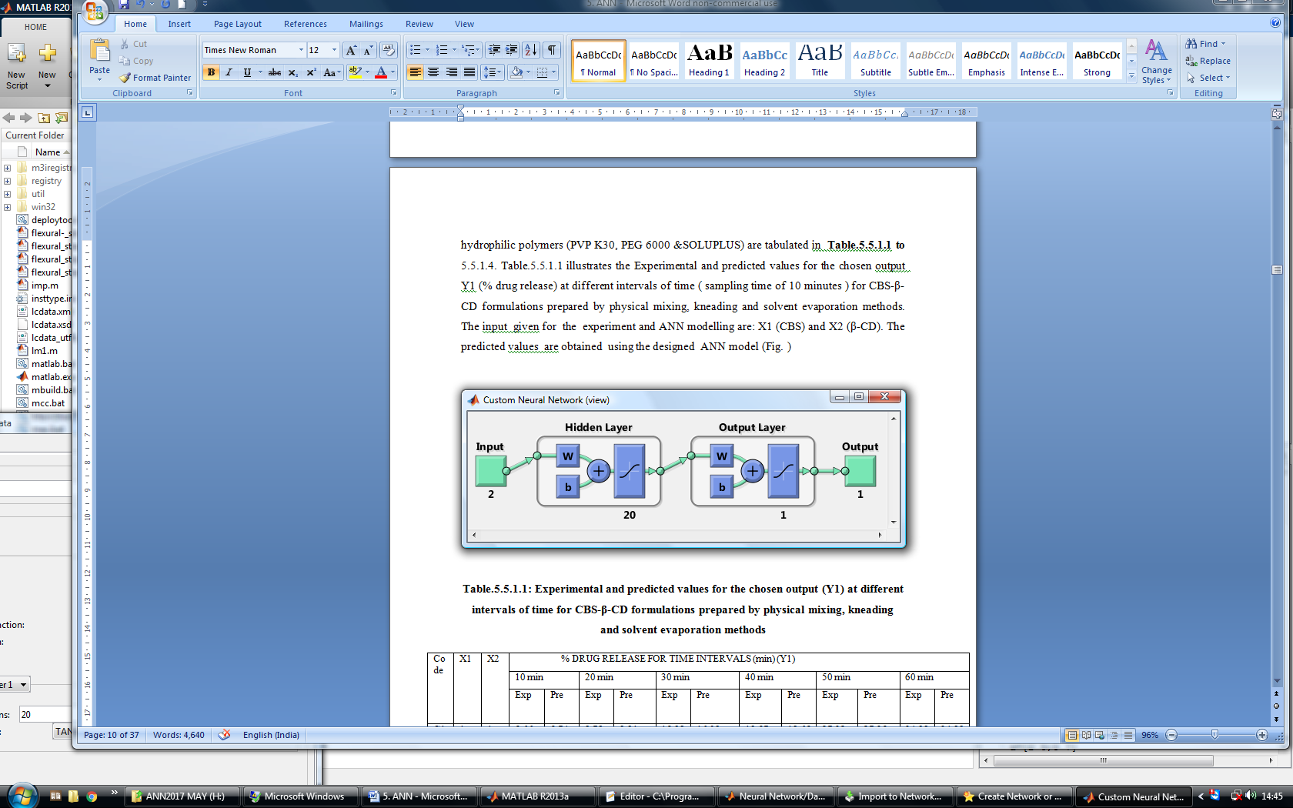

**Figure 4.3.1.1.1: Neural network design for prediction of Y1 (% drug release)**

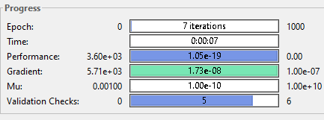

**Figure 4.3.1.1.2: Progress of the ANN during training progress for prediction of Y1**

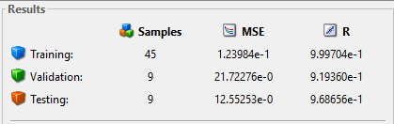

**Figure 4.3.1.1.3: MSE and R variation of designed ANN during training to testing process for prediction of Y1**

**Figure 4.3.1.1.4** shows the performance graph for experimental and predicted values of CBS-β-CD formulations prepared by physical mixing, kneading and solvent evaporation methods and the performance (MSE) graphs for training, validation, testing, and process for number of epochs. The best validation performance was 21.2358 which were observed at epoch 5, as indicated in **Figure 4.3.1.1.4** showing no noticeable problems. The validation and the test curves do not indicate overfitting. The training curve diminishes more than the validation curve implying that the performance of the trained network with learning data is better than the one with the data not involved in the learning process.

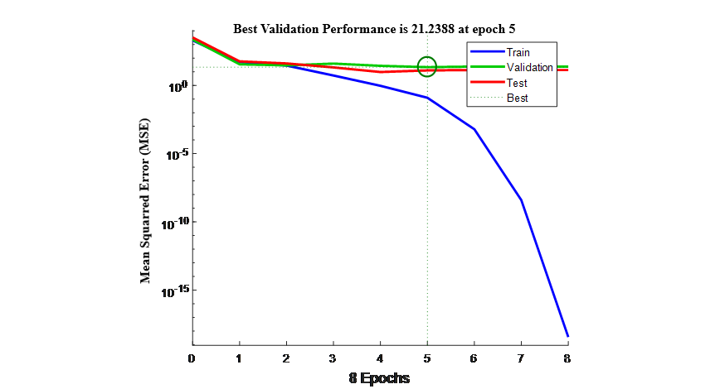

**Figure 4.3.1.1.4: MSE of Train, Test, validation stages vs. No. of epochs for prediction of output Y1**

**Figure****4.3.1.1.5** shows the error histogram of CBS-β-CD formulations with 20 bins of the trained neural network for the training, validation and testing steps represented by blue, green and red bars respectively. Most of the data fall on zero error line which provides an idea to determine if the data is bad or if those data points are different from the rest of the data set.

In this, most of the errors fall between -0.4449 and 0.2978; there is a training point with an error of 1.041 and validation points with errors of -11.59 and -1.93. This figure is used to obtain additional verification of network performance. It also shows that the data fitting errors are distributed within a reasonably good range around zero.



**Figure 4.3.1.1.5: Error histogram for experimental and predicted values for CBS-β-CD formulations prepared by physical mixing, kneading and solvent evaporation methods**

**Figure** **4.3.1.1.6** shows the regression data for experimental and predicted values of CBS-β-CD formulations prepared by physical mixing, kneading and solvent evaporation methods.This is used to validate the network performance. The regression plots display the network outputs with respect to targets for training, validation, and test sets. For a perfect fit, the data should fall along a 45 degree line, where the network outputs are equal to the targets. Here, the fit is reasonably good for all data sets, with R values in each case of 0.91396 or more.



**Figure 4.3.1.1.6: Regression data for experimental and predicted values for CBS-β-CD formulations prepared by physical mixing, kneading and solvent evaporation methods**

**4.3.1.2. Experimental and predicted values for chosen outputs of CBS and its various -β-CD-complexes with hydrophilic polymers**

The experimental and predicted values for the chosen output Y1 (% drug release) at different sampling time (10 min ) for CBS-β-CD-PVP K30, CBS-β-CD-PEG 6000 and CBS-β-CD-soluplus complex systems prepared by the optimized kneading method (formulated in ratios 1:1.5:1,1:1.5:1.5 &1:1.5:2) in 0.1 N HCl and pH 6.8 phosphate buffer are illustrated in **Table 4.3.1.2.1** & **4.3.1.2.2**. It was observed from the tables that the ANN model with 5 inputs and 20 nodes in hidden layer exhibits the overall best performance. From the **Table 4.3.1.2.1** the mean error of prediction is always lower than 0.3265 and the standard deviation observed in testing is 0.1885 and from the **Table 4.3.1.2.2** the mean error of prediction is always lower than 0.1053 and the standard deviation observed in testing is 0.1482. **Table 4.3.1.2.1** & **4.3.1.2.2** illustrates that the proposed method has a very good ability to predict the original parameters of the very good system, using the response features that were defined for the system.

**Table 4.3.1.2.2: Experimental and predicted values for the chosen output (Y1) at different intervals of time for CBS-β-CD-PVP K30, CBS-β-CD-PEG 6000 and CBS-β-CD-soluplus complex systems prepared by the optimized kneading method 0.1 N HCl**

|  |  |  |  |  |  |  |  |  |  |  |  |  |
| --- | --- | --- | --- | --- | --- | --- | --- | --- | --- | --- | --- | --- |
| Time  (min) | Code | **% DRUG RELEASE FOR TIME INTERVALS (min) (Y1)** | | | | | | | | | | |
| **C10** | **C11** | **C12** | **C13** | **C14** | **C15** | **C16** | **C17** | **C18** | **MSE** | **STD** |
| X1 | 1 | 1 | 1 | 1 | 1 | 1 | 1 | 1 | 1 |
| X2 | 1.5 | 1.5 | 1.5 | 1.5 | 1.5 | 1.5 | 1.5 | 1.5 | 1.5 |
| X3 | 1 | 1.5 | 2 | - | - | - | - | - | - |
| X4 | - | - | - | 1 | 1.5 | 2 | - | - | - |
| X5 | - | - | - | - | - | - | 1 | 1.5 | 2 |
| 10 | Exp | 34.98 | 34.80 | 35.75 | 27.07 | 29.85 | 28.70 | 35.15 | 37.01 | 35.15 | 0.5425 | 0.1213 |
| Pre | 34.11 | 34.17 | 36.22 | 27.57 | 29.37 | 29.67 | 35.85 | 37.45 | 35.68 |
| 20 | Exp | 45.25 | 46.27 | 48.05 | 36.09 | 41.13 | 40.06 | 48.18 | 46.12 | 49.26 | 0.3844 | 0.1286 |
| Pre | 45.17 | 46.29 | 49.45 | 37.39 | 42.54 | 41.34 | 48.49 | 46.43 | 50.83 |
| 30 | Exp | 59.21 | 60.17 | 58.69 | 52.33 | 50.17 | 49.53 | 66.03 | 68.16 | 70.51 | 0.2665 | 0.2093 |
| Pre | 59.43 | 60.86 | 58.33 | 52.36 | 51.86 | 50.23 | 66.76 | 68.72 | 70.64 |
| 40 | Exp | 68.18 | 66.11 | 67.74 | 68.39 | 67.29 | 66.24 | 77.96 | 82.48 | 83.35 | 0.8117 | 0.9291 |
| Pre | 68.92 | 66.02 | 67.13 | 68.26 | 67.17 | 66.06 | 78.13 | 82.98 | 83.68 |
| 50 | Exp | 82.93 | 78.37 | 78.15 | 73.88 | 76.52 | 80.64 | 91.64 | 92.53 | 88.57 | 0.1656 | 0.0729 |
| Pre | 82.66 | 78.94 | 78.99 | 73.04 | 76.17 | 80.28 | 92.21 | 92.87 | 88.29 |
| 60 | Exp | 95.96 | 97.81 | 96.78 | 92.74 | 94.83 | 95.75 | 97.47 | 95.29 | 96.03 | 0.0453 | 0.9440 |
| Pre | 95.43 | 97.29 | 96.31 | 92.57 | 94.55 | 96.42 | 97.23 | 95.74 | 96.33 |
| 65 | Exp | 100.15 | 99.24 | 98.65 | 99.72 | 100.04 | 99.22 | 100.01 | 100.59 | 99.12 | 0.0014 | 0.0109 |
| Pre | 100.64 | 99.46 | 98.95 | 99.95 | 100.54 | 99.49 | 100.21 | 100.41 | 99.06 |
| Overall MSE | | | 0.3265 | | | | | | | | | |
| Overall STD | | | 0.1885 | | | | | | | | | |

*Exp= Experimental

*Pre= Predicted

**Table 4.3.1.2.2: Experimental and predicted values for the chosen output (Y1) at different intervals of time for CBS-β-CD-PVP K30, CBS-β-CD-PEG 6000 and CBS-β-CD-soluplus complex systems prepared by the optimized kneading method pH 6.8 phosphate buffer**

|  |  |  |  |  |  |  |  |  |  |  |  |  |
| --- | --- | --- | --- | --- | --- | --- | --- | --- | --- | --- | --- | --- |
| Time  (min) | Code | **% DRUG RELEASE FOR TIME INTERVALS (min) (Y1)** | | | | | | | | | | |
| **C10** | **C11** | **C12** | **C13** | **C14** | **C15** | **C16** | **C17** | **C18** | **MSE** | **STD** |
| X1 | 1 | 1 | 1 | 1 | 1 | 1 | 1 | 1 | 1 |
| X2 | 1.5 | 1.5 | 1.5 | 1.5 | 1.5 | 1.5 | 1.5 | 1.5 | 1.5 |
| X3 | 1 | 1.5 | 2 | - | - | - | - | - | - |
| X4 | - | - | - | 1 | 1.5 | 2 | - | - | - |
| X5 | - | - | - | - | - | - | 1 | 1.5 | 2 |
| 10 | Exp | 31.00 | 31.46 | 32.86 | 25.89 | 27.97 | 26.45 | 31.26 | 33.44 | 31.77 | 0.6127 | 0.1325 |
| Pre | 31.42 | 31.87 | 32.22 | 26.12 | 28.25 | 27.14 | 32.44 | 34.09 | 32.14 |
| 20 | Exp | 41.16 | 43.72 | 45.81 | 34.13 | 39.24 | 38.91 | 43.99 | 42.83 | 45.63 | 0.4504 | 0.1664 |
| Pre | 42.22 | 43.15 | 45.94 | 34.47 | 40.63 | 39.11 | 44.06 | 43.25 | 46.13 |
| 30 | Exp | 56.49 | 57.24 | 55.54 | 50.64 | 48.42 | 47.84 | 62.08 | 64.24 | 64.76 | 0.2981 | 0.2106 |
| Pre | 55.15 | 58.22 | 55.01 | 50.12 | 48.87 | 48.34 | 62.49 | 64.82 | 65.15 |
| 40 | Exp | 65.10 | 63.88 | 64.16 | 66.24 | 65.76 | 64.93 | 73.82 | 78.30 | 79.02 | 0.7826 | 0.8778 |
| Pre | 66.11 | 63.30 | 64.53 | 66.44 | 65.21 | 64.51 | 73.56 | 78.15 | 79.22 |
| 50 | Exp | 79.96 | 75.99 | 75.50 | 71.79 | 74.59 | 78.49 | 87.47 | 89.30 | 84.83 | 0.1911 | 0.0999 |
| Pre | 79.18 | 75.20 | 76.12 | 72.62 | 75.34 | 79.15 | 88.13 | 89.61 | 84.48 |
| 60 | Exp | 85.77 | 81.83 | 82.57 | 78.31 | 81.43 | 84.84 | 90.36 | 91.23 | 87.56 | 0.3114 | 0.8584 |
| Pre | 86.07 | 82.25 | 82.32 | 78.01 | 82.77 | 85.44 | 90.99 | 92.85 | 88.21 |
| 80 | Exp | 92.48 | 94.68 | 93.64 | 89.84 | 92.60 | 89.76 | 94.74 | 95.68 | 94.99 | 0.2287 | 0.1017 |
| Pre | 92.64 | 95.02 | 94.32 | 90.41 | 93.47 | 90.11 | 95.34 | 96.12 | 95.05 |
| 90 | Exp | 100.74 | 99.31 | 100.59 | 94.15 | 96.89 | 94.11 | 100.03 | 100.95 | 100.34 | 0.1023 | 0.1992 |
| Pre | 100.43 | 99.52 | 100.88 | 95.36 | 96.21 | 94.52 | 99.65 | 100.49 | 100.03 |
| 100 | Exp | - | - | - | 100.70 | 100.09 | 99.01 | - | - | - | 0.1169 | 0.1482 |
| Pre | - | - | - | 100.23 | 99.91 | 99.16 | - | - | - |
| Overall MSE | | | 0.1053 | | | | | | | | | |
| Overall STD | | | 0.1482 | | | | | | | | | |

*Exp= Experimental

*Pre= Predicted

The network with five inputs, 20 hidden neurons and LM training algorithm was finally chosen to keep the complexity of the network within limits. **Figure** **4.3.1.2.1** shows the structure of the selected network. The inputs given are: X1 (CBS), X2 (β-CD) and X3 (PVP K30), X4 (PEG 6000), X5 (SOLUPLUS). The predicted values are obtained using the designed (2 layered ANN with 20 nodes in hidden layer architecture) ANN model. **Figure 4.3.1.2.2** shows the progress of the ANN during training progress for prediction of Y1. **Figure 4.3.1.2.3** shows the MSE and R variation of designed ANN during training (45 samples) to testing (9 samples) process for prediction of Y1.

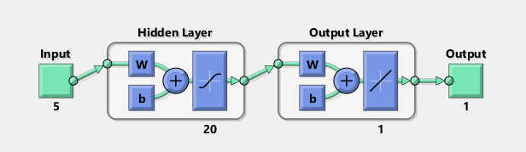

**Figure 4.3.1.2.1: Neural network design for prediction of Y1 (% drug release)**

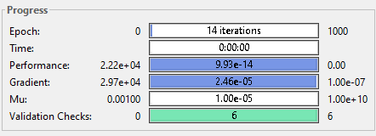

**Figure 4.3.1.2.2: Progress of the ANN during training progress for prediction of Y1**

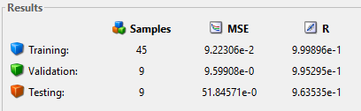

**Figure 4.3.1.2.3: MSE and (R) variation of designed ANN during training to testing process for prediction of Y1**

**Figure 4.3.1.2.4** shows the performance (variation of MSE) of the predicted values of CBS with hydrophilic polymers, where the performance plot shows no noticeable problems. The best validation performance was 10.0128 observed at epoch 8 as indicated in the figure.The validation and the test curves do not indicate overfitting and the training curve diminishes more than the validation curve and this way, represents that, the performance of the trained network with learning data is better than the one with the data not involved in the learning process.

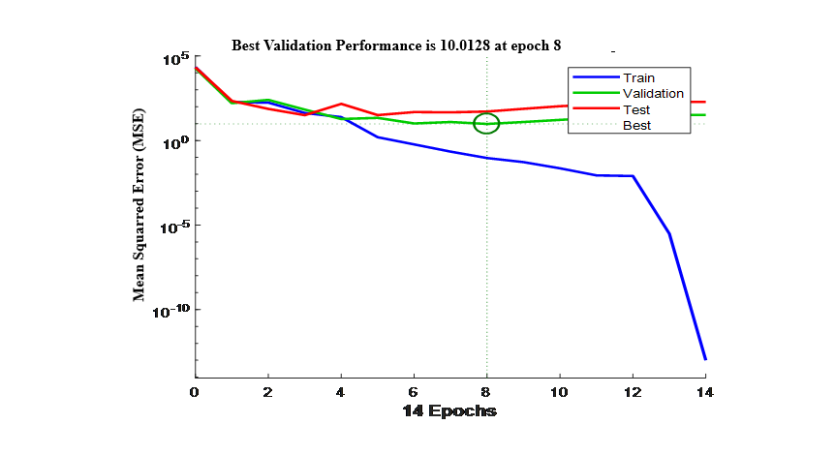

**Figure 4.3.1.2.4: Performance for experimental and predicted values for CBS-β-CD-PVP K30, CBS-β-CD-PEG 6000 and CBS-β-CD-soluplus complex systems prepared by the optimized kneading method**

**Figure 4.3.1.2.5** illustrates the error histogram for CBS-β-CD-PVP K30, CBS-β-CD-PEG 6000 and CBS-β-CD-soluplus complex systems prepared by the optimized kneading method with 20 bins of the trained neural network for the training, validation and testing steps represented by the blue, green and red bars respectively. The most data fall on zero error line which provides an idea to check the outliers to determine if the data is bad, or if those data points are different than the rest of the data set. In this case, most errors fall between -0.2494 and 0.8189, there is a training point with an error of -2.386 and validation points with errors of 4.024 and 5.092. If the outliers are valid data points, but are unlike the rest of the data, then the network is extrapolating for these points. This figure is used to obtain additional verification of network performance. It also shows that the data fitting errors are distributed within a reasonably good range around zero.



**Figure 4.3.1.2.5: Error histogram for CBS-β-CD-PVP K30, CBS-β-CD-PEG 6000 and CBS-β-CD-soluplus complex systems prepared by the optimized kneading method**

**Figure 4.3.1.2.6** shows the regression data for experimental and predicted values of CBS with hydrophilic polymers. This is used to validate the network performance. The regression plots display the network outputs with respect to targets for training, validation, and test sets. For a perfect fit, the data should fall along a 45 degree line, where the network outputs are equal to the targets. Here, the fit is reasonably good for all data sets, with R values in each case being 0.96354 or more.



**Figure 4.3.1.2.6: Regression data of CBS-β-CD-PVP K30, CBS-β-CD-PEG 6000 and CBS-β-CD-soluplus complex systems prepared by the optimized kneading method**

**4.3.1.3 Experimental and predicted values for chosen outputs of CBS and its various HP-β-CD-complexes without hydrophilic polymers**

The experimental and predicted values for the chosen output Y1 (% drug release) at different sampling time (10 min) for CBS-HP-β-CD formulations prepared by physical mixing, kneading and solvent evaporation methods in 0.1 N HCl and pH 6.8 phosphate buffer are given in **Table 4.3.1.3.1** & **4.3.1.3.2**. It is observed that the ANN model with 2 inputs and 25 nodes in hidden layer exhibits the overall best performance. From the **Table 4.3.1.3.1** the mean error of prediction is always lower than 1.1561 and the standard deviation observed are 0.7658 in testing and from the **Table 4.3.1.3.2** the mean error of prediction is always lower than 0.9972 and the standard deviation observed are 0.7163 in testing. **Table 4.3.1.3.1** & **4.3.1.3.2** also demonstrates that the proposed method has a very good ability to predict the original parameters of the very good system, using the response features that were defined for the system.

**Table 4.3.1.3.1: Experimental and predicted values for the chosen output (Y1) at different intervals of time for CBS-HP-β-CD formulations prepared by physical mixing, kneading and solvent evaporation methods in 0.1 N HCl**

|  |  |  |  |  |  |  |  |  |  |  |  |  |
| --- | --- | --- | --- | --- | --- | --- | --- | --- | --- | --- | --- | --- |
| Time  (min) | Code | **% DRUG RELEASE FOR TIME INTERVALS (min) (Y1)** | | | | | | | | | | |
| **C19** | **C20** | **C21** | **C22** | **C23** | **C24** | **C25** | **C26** | **C27** | **MSE** | **STD** |
| X1 | 1 | 1 | 1 | 1 | 1 | 1 | 1 | 1 | 1 |
| X2 | 1 | 1.5 | 2 | 1 | 1.5 | 2 | 1 | 1.5 | 2 |
| 10 | Exp | 17.54 | 18.33 | 16.62 | 25.72 | 26.35 | 25.18 | 26.82 | 23.67 | 24.25 | 0.1356 | 0.2312 |
| Pre | 18.29 | 18.90 | 16.25 | 26.35 | 25.64 | 25.77 | 26.14 | 23.98 | 24.72 |
| 20 | Exp | 25.91 | 23.79 | 27.26 | 38.99 | 39.21 | 39.04 | 40.16 | 33.08 | 34.37 | 0.2653 | 0.1923 |
| Pre | 26.26 | 23.12 | 27.85 | 39.33 | 39.63 | 39.62 | 40.75 | 33.64 | 34.14 |
| 30 | Exp | 39.46 | 36.93 | 36.64 | 45.58 | 49.40 | 48.39 | 51.46 | 50.13 | 49.46 | 0.1679 | 1.1285 |
| Pre | 39.09 | 37.28 | 36.32 | 45.04 | 49.84 | 48.75 | 52.22 | 50.42 | 49.23 |
| 40 | Exp | 56.02 | 55.93 | 54.60 | 65.41 | 62.44 | 69.41 | 65.90 | 66.06 | 64.19 | 0.1143 | 0.1049 |
| Pre | 56.24 | 56.06 | 54.17 | 65.95 | 62.82 | 69.53 | 65.14 | 66.39 | 64.82 |
| 50 | Exp | 68.35 | 67.59 | 68.81 | 74.23 | 75.25 | 76.24 | 71.03 | 70.23 | 72.76 | 0.0358 | 0.7117 |
| Pre | 68.73 | 68.16 | 68.99 | 74.65 | 75.77 | 76.86 | 71.56 | 70.51 | 72.15 |
| 60 | Exp | 84.43 | 82.94 | 82.76 | 92.54 | 91.13 | 91.23 | 92.04 | 90.63 | 90.01 | 0.2014 | 0.1656 |
| Pre | 84.87 | 83.23 | 83.03 | 92.79 | 91.45 | 91.65 | 92.54 | 90.98 | 90.49 |
| 70 | Exp | 96.43 | 95.11 | 99.21 | 100.25 | 98.22 | 98.67 | 97.19 | 96.33 | 99.01 | 0.1321 | 0.2792 |
| Pre | 96.21 | 95.62 | 99.42 | 100.38 | 98.14 | 98.19 | 97.84 | 95.09 | 99.45 |
| 75 | Exp | 100.63 | 100.32 | - | - | - | - | 100.25 | 100.59 | - | 0.0148 | 0.0389 |
| Pre | 100.39 | 100.16 |  |  |  |  | 100.12 | 100.87 |  |
| Overall MSE | | | 1.1561 | | | | | | | | | |
| Overall STD | | | 0.7658 | | | | | | | | | |

*Exp= Experimental

*Pre= Predicted

**Table 4.3.1.3.2: Experimental and predicted values for the chosen output (Y1) at different intervals of time for CBS-HP-β-CD formulations prepared by physical mixing, kneading and solvent evaporation methods in pH 6.8 phosphate buffer**

|  |  |  |  |  |  |  |  |  |  |  |  |  |
| --- | --- | --- | --- | --- | --- | --- | --- | --- | --- | --- | --- | --- |
| Time  (min) | Code | **% DRUG RELEASE FOR TIME INTERVALS (min) (Y1)** | | | | | | | | | | |
| **C19** | **C20** | **C21** | **C22** | **C23** | **C24** | **C25** | **C26** | **C27** | **MSE** | **STD** |
| X1 | 1 | 1 | 1 | 1 | 1 | 1 | 1 | 1 | 1 |
| X2 | 1 | 1.5 | 2 | 1 | 1.5 | 2 | 1 | 1.5 | 2 |
| 10 | Exp | 9.37 | 10.22 | 11.72 | 12.29 | 12.40 | 13.19 | 11.54 | 11.33 | 12.49 | 0.2421 | 0.2543 |
| Pre | 10.34 | 10.61 | 11.89 | 12.51 | 12.64 | 13.50 | 11.69 | 11.76 | 12.73 |
| 20 | Exp | 15.46 | 17.82 | 18.31 | 19.02 | 20.61 | 18.31 | 20.15 | 21.67 | 19.92 | 0.2812 | 0.2075 |
| Pre | 16.00 | 18.60 | 18.69 | 19.39 | 20.81 | 19.14 | 20.67 | 21.83 | 20.91 |
| 30 | Exp | 24.88 | 25.13 | 27.45 | 30.50 | 31.87 | 30.39 | 31.27 | 32.27 | 30.24 | 0.2532 | 0.1363 |
| Pre | 25.36 | 25.64 | 28.19 | 30.85 | 32.05 | 30.67 | 31.93 | 32.71 | 30.76 |
| 40 | Exp | 27.25 | 29.82 | 28.67 | 35.26 | 36.70 | 34.61 | 37.26 | 38.16 | 39.54 | 0.2257 | 0.1418 |
| Pre | 27.97 | 30.80 | 29.35 | 35.78 | 37.26 | 35.07 | 37.53 | 38.97 | 40.13 |
| 50 | Exp | 40.77 | 41.74 | 40.93 | 46.52 | 50.25 | 48.69 | 46.19 | 47.10 | 45.49 | 0.3023 | 0.6620 |
| Pre | 41.51 | 41.91 | 41.32 | 47.12 | 50.80 | 49.55 | 46.80 | 47.81 | 46.03 |
| 60 | Exp | 46.51 | 49.72 | 52.60 | 59.14 | 58.43 | 59.42 | 57.15 | 56.12 | 57.13 | 0.1214 | 0.1743 |
| Pre | 47.16 | 50.15 | 52.86 | 60.05 | 58.91 | 59.91 | 57.86 | 56.73 | 57.84 |
| 80 | Exp | 67.04 | 70.13 | 72.21 | 69.58 | 71.53 | 80.14 | 78.61 | 78.59 | 80.73 | 0.1553 | 0.1881 |
| Pre | 67.51 | 70.50 | 72.42 | 70.53 | 71.68 | 80.32 | 79.47 | 79.44 | 80.23 |
| 90 | Exp | 86.34 | 87.85 | 86.64 | 80.24 | 90.25 | 100.87 | 89.94 | 98.55 | 92.98 | 0.0534 | 0.6960 |
| Pre | 86.97 | 88.63 | 87.30 | 80.52 | 89.73 | 100.99 | 89.06 | 98.95 | 93.24 |
| 100 | Exp | 99.31 | 98.67 | 99.26 | 99.14 | 100.08 | - | 98.45 | - | 100.66 | 0.6048 | 0.6890 |
| Pre | 99.89 | 98.11 | 98.96 | 99.58 | 100.79 | - | 99.13 | - | 100.27 |
| Overall MSE | | | 0.9972 | | | | | | | | | |
| Overall STD | | | 0.7163 | | | | | | | | | |

*Exp= Experimental

*Pre= Predicted

The inputs given for the experiment and ANN modelling are: X1 (CBS), X2 (HP-β-CD). To keep the complexity of the network within limits and in order to minimize the risk of overfitting condition, the network with two inputs, 25 hidden neurons and LM training algorithm was finally chosen. **Figure** **4.3.1.3.1** shows the structure of the selected neural network. The progress of the ANN during training progress for prediction of Y1 is shown in **Figure 4.3.1.3.2**. **Figure 4.3.1.3.3** shows the MSE and (R) variation of designed ANN during training (45 samples) to testing (9 samples) process for prediction of Y1.



**Figure 4.3.1.3.1: Neural network design for prediction of Y1 (% drug release)**

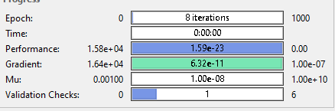

**Figure 4.3.1.3.2: Progress of the ANN during training progress for prediction of Y1**

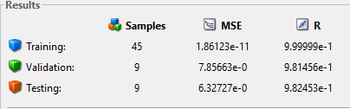

**Figure 4.3.1.3.3: MSE and (R) variation of designed ANN during training to testing process for prediction of Y1**

**Figure 4.3.1.3.4** shows the performance graph with 25 hidden nodes for experimental and predicted values of CBS-HP-β-CD formulations prepared by physical mixing, kneading and solvent evaporation methods. The best validation performance was 7.4024 observed at epoch 7 as indicated in **Figure 4.3.1.3.4**. The validation and the test curves do not indicate overfitting. The training curve diminishes more than the validation curve representing the performance of the trained network with learning data is better than with the data not involved in the learning process

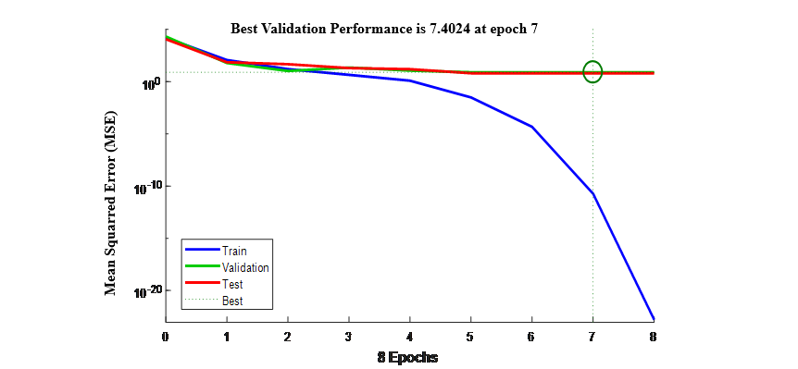

**Figure 4.3.1.3.4: Performance data for experimental and predicted values CBS-HP-β-CD formulations prepared by physical mixing, kneading and solvent evaporation methods**

**Figure****4.3.1.3.5** shows the error histogram with 20 bins of the trained neural network for the training, validation and testing steps represented by blue, green and red bars respectively. The most data fall on zero error line which provides an idea to determine if the data is bad, or if those data points are different than the rest of the data set. In this case, errors fall between 0 and 0.2517; there is a training point with an error of zero and validation points with errors of 3.898 and 4.419. It is used to obtain additional verification of network performance. It also shows that the data fitting errors are distributed within a reasonably good range around zero.



**Figure 4.3.1.3.5: Error histogram for experimental and predicted values CBS-HP-β-CD formulations prepared by physical mixing, kneading and solvent evaporation methods**

**Figure 4.3.1.3.6** shows the regression data for experimental and predicted values of CBS-HP-β-CD formulations prepared by the optimized kneading and solvent evaporation methods. This is used to validate the network performance. The regression plots display the network outputs with respect to targets for training, validation, and test sets. For a perfect fit, the data should fall along a 45 degree line, where the network outputs are equal to the targets. Here, the fit is reasonably good for all data sets, with R values in each case of 0.98146 or above.



**Figure 4.3.1.3.6: Regression data for experimental and predicted values CBS-HP-β-CD formulations prepared by physical mixing, kneading and solvent evaporation methods**

**4.3.1.4 Experimental and predicted values for chosen outputs of CBS and its various HP-β-CD -complexes with hydrophilic polymers**

The experimental and predicted values for the chosen output Y1 (% drug release) at different intervals of time (sampling time of 10 minutes) for CBS-HP-β-CD-PVP K30, CBS-HP-β-CD-PEG 6000 and CBS-HP-β-CD-soluplus complex systems prepared by the optimized kneading method (formulated in ratios 1:1:1,1:1:1.5 &1:1:2) in 0.1 N HCl and pH 6.8 phosphate buffer are illustrated in **Table 4.3.1.4.1** & **4.3.1.4.2**. It was observed that the ANN model with 5 inputs and 22 nodes in hidden layer exhibits the overall best performance. From the **Table** **4.3.1.4.1** the mean error of prediction is always lower than 0.4781 and the standard deviation observed are 0.3214 in testing and from the **Table 4.3.1.4.2** the mean error of prediction is always lower than 0.5616 and the standard deviation observed are 0.3531 in testing. **Table 4.3.1.4.1** & **4.3.1.4.2** also illustrates that the proposed method has a very good ability to predict the original parameters of the very good system, using the response features that were defined for the system.

**Table 4.3.1.4.1: Experimental and predicted values for the chosen output (Y1) at different intervals of time for CBS-HP-β-CD-PVP K30, CBS-HP-β-CD-PEG 6000 and CBS-HP-β-CD-soluplus complex systems prepared by the optimized kneading method 0.1 N HCl**

|  |  |  |  |  |  |  |  |  |  |  |  |  |
| --- | --- | --- | --- | --- | --- | --- | --- | --- | --- | --- | --- | --- |
| Time  (min) | Code | **% DRUG RELEASE FOR TIME INTERVALS (min) (Y1)** | | | | | | | | | | |
| **C28** | **C29** | **C30** | **C31** | **C32** | **C33** | **C34** | **C35** | **C36** | **MSE** | **STD** |
| X1 | 1 | 1 | 1 | 1 | 1 | 1 | 1 | 1 | 1 |
| X2 | 1 | 1 | 1 | 1 | 1 | 1 | 1 | 1 | 1 |
| X3 | 1 | 1.5 | 2 | - | - | - | - | - | - |
| X4 | - | - | - | 1 | 1.5 | 2 | - | - | - |
| X5 | - | - | - | - | - | - | 1 | 1.5 | 2 |
| 10 | Exp | 47.14 | 48.09 | 45.13 | 44.27 | 40.12 | 41.99 | 61.28 | 53.39 | 54.32 | 0.4238 | 0.3541 |
| Pre | 47.85 | 48.98 | 45.64 | 44.69 | 40.33 | 42.90 | 61.49 | 53.72 | 54.75 |
| 20 | Exp | 59.71 | 61.24 | 63.92 | 58.25 | 50.02 | 49.39 | 77.46 | 68.81 | 65.53 | 0.2729 | 0.1978 |
| Pre | 58.74 | 61.12 | 63.53 | 59.07 | 50.54 | 50.32 | 78.20 | 67.93 | 65.18 |
| 30 | Exp | 70.98 | 73.53 | 75.01 | 69.16 | 68.39 | 71.24 | 89.28 | 74.40 | 76.16 | 0.1028 | 0.2063 |
| Pre | 70.48 | 73.28 | 75.22 | 70.07 | 69.22 | 71.36 | 90.20 | 74.84 | 76.77 |
| 40 | Exp | 76.50 | 85.44 | 82.58 | 84.28 | 77.62 | 76.07 | 93.59 | 86.22 | 89.60 | 0.8664 | 0.6462 |
| Pre | 77.15 | 85.98 | 82.83 | 84.70 | 78.11 | 76.64 | 93.09 | 86.46 | 89.02 |
| 50 | Exp | 85.68 | 93.64 | 94.73 | 94.70 | 83.08 | 87.58 | 96.64 | 93.47 | 95.66 | 0.2583 | 0.7618 |
| Pre | 86.24 | 94.00 | 95.20 | 95.17 | 83.46 | 88.33 | 97.30 | 93.81 | 96.22 |
| 60 | Exp | 97.24 | 99.04 | 98.82 | 98.65 | 99.64 | 98.98 | 100.23 | 99.70 | 99.03 | 0.9760 | 0.3398 |
| Pre | 97.96 | 99.31 | 97.70 | 98.15 | 99.22 | 99.10 | 100.52 | 99.49 | 99.46 |
| Overall MSE | | | 0.4718 | | | | | | | | | |
| Overall STD | | | 0.3214 | | | | | | | | | |

*Exp= Experimental

*Pre= Predicted

**Table 4.3.1.4.2: Experimental and predicted values for the chosen output (Y1) at different intervals of time for CBS-HP-β-CD-PVP K30, CBS-HP-β-CD-PEG 6000 and CBS-HP-β-CD-soluplus complex systems prepared by the optimized kneading method pH 6.8 phosphate buffer**

|  |  |  |  |  |  |  |  |  |  |  |  |  |
| --- | --- | --- | --- | --- | --- | --- | --- | --- | --- | --- | --- | --- |
| Time  (min) | Code | **% DRUG RELEASE FOR TIME INTERVALS (min) (Y1)** | | | | | | | | | | |
| **C28** | **C29** | **C30** | **C31** | **C32** | **C33** | **C34** | **C35** | **C36** | **MSE** | **STD** |
| X1 | 1 | 1 | 1 | 1 | 1 | 1 | 1 | 1 | 1 |
| X2 | 1 | 1 | 1 | 1 | 1 | 1 | 1 | 1 | 1 |
| X3 | 1 | 1.5 | 2 | - | - | - | - | - | - |
| X4 | - | - | - | 1 | 1.5 | 2 | - | - | - |
| X5 | - | - | - | - | - | - | 1 | 1.5 | 2 |
| 10 | Exp | 44.45 | 44.10 | 42.86 | 41.66 | 37.05 | 38.66 | 50.84 | 48.57 | 47.01 | 0.3544 | 0.4252 |
| Pre | 44.89 | 44.51 | 43.14 | 41.82 | 37.78 | 39.52 | 51.64 | 49.42 | 47.71 |
| 20 | Exp | 56.84 | 59.61 | 60.96 | 55.38 | 47.55 | 46.09 | 73.55 | 64.01 | 62.08 | 0.3229 | 0.2019 |
| Pre | 57.52 | 60.57 | 61.62 | 55.91 | 48.30 | 46.78 | 73.90 | 64.51 | 62.36 |
| 30 | Exp | 67.80 | 70.23 | 72.27 | 66.83 | 65.98 | 68.91 | 83.49 | 70.98 | 74.33 | 0.2196 | 0.3423 |
| Pre | 68.58 | 70.55 | 72.49 | 67.51 | 66.57 | 69.80 | 83.83 | 71.78 | 74.76 |
| 40 | Exp | 73.62 | 82.68 | 77.07 | 78.93 | 74.88 | 72.34 | 89.07 | 82.43 | 85.72 | 0.6204 | 0.7226 |
| Pre | 73.98 | 82.94 | 77.77 | 78.24 | 74.16 | 72.78 | 89.56 | 82.67 | 86.29 |
| 50 | Exp | 82.84 | 90.65 | 87.76 | 83.47 | 80.93 | 81.16 | 95.41 | 90.93 | 88.34 | 0.7535 | 0.2790 |
| Pre | 82.44 | 90.12 | 88.21 | 83.83 | 80.36 | 81.75 | 95.15 | 90.35 | 88.78 |
| 60 | Exp | 86.87 | 92.37 | 90.98 | 86.13 | 84.19 | 85.23 | 96.45 | 94.56 | 92.07 | 0.8219 | 0.6462 |
| Pre | 86.16 | 92.80 | 90.18 | 86.42 | 84.84 | 85.52 | 96.21 | 94.05 | 92.54 |
| 80 | Exp | 97.54 | 96.33 | 96.01 | 96.14 | 95.89 | 95.64 | 100.12 | 99.05 | 97.85 | 0.6907 | 0.1159 |
| Pre | 97.23 | 96.36 | 96.35 | 96.55 | 95.31 | 95.12 | 100.31 | 99.42 | 98.13 |
| 90 | Exp | 100.22 | 100.37 | 99.80 | 99.99 | 100.64 | 100.15 | - | - | 100.01 | 0.3323 | 0.2781 |
| Pre | 99.87 | 100.14 | 99.32 | 99.38 | 100.23 | 100.46 | - | - | 100.56 |
| Overall MSE | | | 0.5616 | | | | | | | | | |
| Overall STD | | | 0.3531 | | | | | | | | | |

*Exp= Experimental

*Pre= Predicted

To keep the complexity of the network within limits and in order to minimize the risk of overfitting condition, the network with five inputs, 20 hidden neurons and LM-learning algorithm was finally chosen. **Figure** **4.3.1.4.1** shows the structure of the selected network. The inputs given for the experiment and ANN modelling are: X1 (CBS), X2 (HP-β-CD) and X3(PVP K30), X4 (PEG 6000), X5 (SOLUPLUS). **Figure 4.3.1.4.2** shows the progress of the ANN during training progress for prediction of Y1. The performance of the network obtained is 10.59 × 10-23. **Figure 4.3.1.4.3** shows the MSE and (R) variation of designed ANN during training (45 samples) to testing (9 samples) process for prediction of Y1.

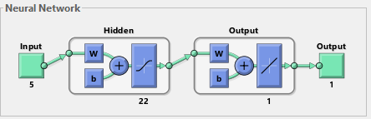

**Figure 4.3.1.4.1: Neural network design for prediction of Y1 (% drug release)**

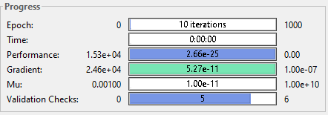

**Figure 4.3.1.4.2: Progress of the ANN during training progress for prediction of Y1**

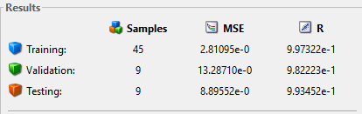

**Figure 4.3.1.4.3: MSE and R variation of designed ANN during training to testing process for prediction of Y1**

**Figure 4.3.1.4.4** shows the performance graph with 22 hidden nodes for experimental and predicted values of CBS with hydrophilic polymers. The best validation performance was 12.9753 observed at epoch 5 as indicated in **Figure 4.3.1.4.4**. The validation and the test curves do not indicate overfitting and they represents that, the performance of the trained network with learning data is better than with the data not involved in the learning process.

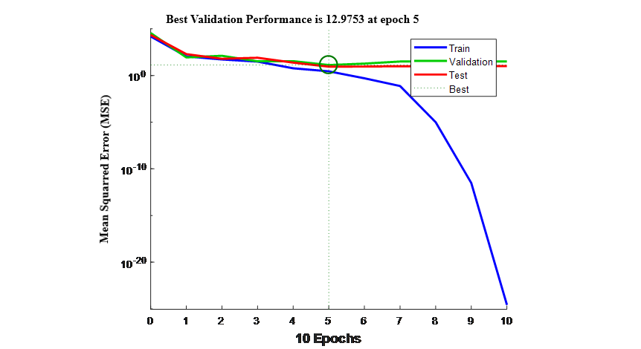

**Figure 4.3.1.4.4: Performance for experimental and predicted values of CBS-HP-β-CD-PVP K30, CBS-HP-β-CD-PEG 6000 and CBS-HP-β-CD-soluplus complex systems prepared by the optimized kneading method**

**Figure** **4.3.1.4.5** shows the error histogram with 20 bins of the trained neural network for the training, validation and testing steps indicated by the blue, green and red bars respectively. The most data fall on zero error line which provides an idea to check if the data is bad, or if those data points are different than the rest of the data set. In this case, most errors fall between -1.638 and 1.341, there is a training point with an error of 5.512 and validation points with errors of 4.917 and 6.108.This figure is used to obtain additional verification of network performance. It also shows that the data fitting errors are distributed within a reasonably good range around zero.



**Figure 4.3.1.4.5: Error histogram for experimental and predicted values of CBS, CBS-HP-β-CD-PVP K30, CBS-HP-β-CD-PEG 6000 and CBS-HP-β-CD-soluplus complex systems prepared by the optimized kneading method**

**Figure 4.3.1.4.6** shows the regression data for experimental and predicted values of CBS-HP-β-CD-PVP K30, CBS-HP-β-CD-PEG 6000 and CBS-HP-β-CD-soluplus complex systems prepared by the optimized kneading method. This is used to validate the network performance. The regression plots display the network outputs with respect to targets for training, validation, and test sets. For a perfect fit, the data should fall along a 45 degree line, where the network outputs are equal to the targets. Here, the fit is reasonably good for all data sets, with R values in each case of 0.9822 or more.



**Figure 4.3.1.4.6: Regression data for experimental and predicted values of CBS-HP-β-CD-PVP K30, CBS-HP-β-CD-PEG 6000 and CBS-HP-β-CD-soluplus complex systems prepared by the optimized kneading method**

**4.3.2. Experimental and predicted values for chosen outputs of DTG-CD-complexes with and without hydrophilic polymers**

The results obtained through ANN modelling to evaluate the influence of cyclodextrins (β-CD, HP-β-CD) on dissolution enhancement of DTG with and without hydrophilic polymers (PVP K30, PEG 6000 & SOLUPLUS) are tabulated infrom **Table 4.3.2.1.1 to 4.3.2.4.2.**

**4.3.2.1 Experimental and predicted values for chosen outputs of DTG-β-CD formulations without hydrophilic polymers**

The two inputs applied for the experiment and designed ANN modelling are: X1 (DTG), X2 (β-CD). The predicted values are obtained using the designed 2-1-20-1 architecture (2 layered ANN architecture with 20 nodes in hidden layer and one output layer) ANN model. As can be seen, the ANN trained with the input data can estimate the predicted parameters with relatively very good precision. **Figure 4.3.2.1.1** below shows the neural network design (2-1-20-1architecture) for prediction of Y1 (% drug release). Each neuron receives input vector (X1, X2) attached with a weight Wi which shows the connection strength for a particular input for each connection. Every input is then multiplied by the corresponding weight of the neuron connection. A bias bi can be defined as a type of connection weight with a constant non-zero value added to the summation of inputs and the corresponding weights Wi.

X2 (β-CD)

X1 (DTG

Output layer with one output

One Hidden layer with 20 neurons

Input layer with 2 inputs

Y1 (% drug release)

Bias

1

2

19

20

**Figure 4.3.2.1.1: ANN model (2-1-20-1architecture) of DTG-β-CD formulations without hydrophilic polymers for prediction of Y1 (% of drug release)**

**Table 4.3.2.1.1** & **4.3.2.1.2** illustrates the experimental and predicted values for the chosen output Y1 (% drug release) at different sampling time (10 min) for DTG-β-CD formulations prepared by physical mixing, kneading and solvent evaporation methods in 0.1 N HCl and pH 6.8 phosphate buffer. It was observed that ANN model with 20 nodes in hidden layer exhibits the overall best performance. From the **Table 4.3.2.1.1** the mean error of prediction is always lower than 0.2815 and the standard deviation observed are 0.1568 in testing, From the **Table 4.3.2.1.2** the mean error of prediction is always lower than 0.1407 and the standard deviation observed are 0.0743 in testing. .  It represents the average squared error difference between actual output values and predicted values. **Table 4.3.2.1.1** & **4.3.2.1.2** shows the proposed method has a very good ability to predict the original parameters of the very good system, using the response features that were defined for the system.

**Table 4.3.2.1.1: Experimental and predicted values for the chosen output (Y1) at different intervals of time for DTG-β-CD formulations prepared by physical mixing, kneading and solvent evaporation methods in 0.1 N HCl**

|  |  |  |  |  |  |  |  |  |  |  |  |  |
| --- | --- | --- | --- | --- | --- | --- | --- | --- | --- | --- | --- | --- |
| Time  (min) | Code | **% DRUG RELEASE FOR TIME INTERVALS (min) (Y1)** | | | | | | | | | | |
| **F1** | **F2** | **F3** | **F4** | **F5** | **F6** | **F7** | **F8** | **F9** | **MSE** | **STD** |
| X1 | 1 | 1 | 1 | 1 | 1 | 1 | 1 | 1 | 1 |
| X2 | 1 | 1.5 | 2 | 1 | 1.5 | 2 | 1 | 1.5 | 2 |
| 10 | Exp | 12.31 | 16.32 | 14.72 | 25.95 | 27.38 | 26.73 | 25.84 | 24.33 | 26.34 | 0.4431 | 0.7804 |
| Pre | 12.54 | 16.95 | 15.19 | 26.54 | 28.11 | 27.40 | 26.42 | 24.76 | 26.97 |
| 20 | Exp | 19.11 | 26.82 | 27.24 | 38.67 | 36.00 | 35.41 | 33.19 | 38.27 | 39.75 | 0.4028 | 0.3534 |
| Pre | 20.23 | 27.50 | 27.96 | 39.53 | 36.22 | 35.95 | 33.50 | 39.09 | 40.72 |
| 30 | Exp | 22.15 | 38.82 | 33.78 | 42.04 | 49.03 | 48.39 | 50.63 | 47.52 | 49.03 | 0.3127 | 0.2064 |
| Pre | 22.36 | 39.70 | 34.15 | 42.28 | 49.96 | 49.22 | 51.19 | 48.27 | 49.96 |
| 40 | Exp | 48.23 | 52.88 | 53.12 | 56.83 | 60.33 | 59.80 | 54.18 | 55.82 | 60.89 | 0.2927 | 0.1285 |
| Pre | 49.05 | 53.16 | 53.43 | 57.51 | 60.54 | 60.10 | 54.59 | 56.40 | 61.57 |
| 50 | Exp | 56.41 | 61.31 | 72.30 | 70.04 | 71.88 | 73.92 | 76.88 | 74.54 | 75.19 | 0.7428 | 0.4516 |
| Pre | 57.05 | 61.44 | 72.53 | 70.45 | 72.06 | 74.31 | 77.56 | 74.99 | 75.70 |
| 60 | Exp | 78.04 | 80.05 | 81.15 | 82.13 | 84.23 | 83.52 | 82.46 | 83.17 | 82.11 | 0.2319 | 0.5391 |
| Pre | 78.82 | 81.05 | 81.68 | 82.86 | 84.65 | 83.87 | 82.88 | 83.48 | 82.32 |
| 70 | Exp | 88.34 | 91.38 | 93.77 | 94.32 | 100.98 | 99.02 | 98.62 | 99.15 | 92.81 | 0.0901 | 0.3288 |
| Pre | 89.17 | 91.51 | 94.14 | 94.75 | 100.67 | 99.45 | 99.02 | 99.66 | 93.00 |
| 80 | Exp | 100.14 | 99.57 | 98.54 | 100.74 | - | - | - | - | 100.23 | 0.4281 | 0.2103 |
| Pre | 100.47 | 99.98 | 98.80 | 100.32 | - | - | - | - | 100.51 |
| Overall MSE | | | 0.2815 | | | | | | | | | |
| Overall STD | | | 0.1568 | | | | | | | | | |

*Exp= Experimental

*Pre= Predicted

**Table 4.3.2.1.2: Experimental and predicted values for the chosen output (Y1) at different intervals of time for DTG-β-CD formulations prepared by physical mixing, kneading and solvent evaporation methods in pH 6.8 phosphate buffer**

|  |  |  |  |  |  |  |  |  |  |  |  |  |
| --- | --- | --- | --- | --- | --- | --- | --- | --- | --- | --- | --- | --- |
| Time  (min) | Code | **% DRUG RELEASE FOR TIME INTERVALS (min) (Y1)** | | | | | | | | | | |
| **F1** | **F2** | **F3** | **F4** | **F5** | **F6** | **F7** | **F8** | **F9** | **MSE** | **STD** |
| X1 | 1 | 1 | 1 | 1 | 1 | 1 | 1 | 1 | 1 |
| X2 | 1 | 1.5 | 2 | 1 | 1.5 | 2 | 1 | 1.5 | 2 |
| 10 | Exp | 9.87 | 10.37 | 9.98 | 10.94 | 13.84 | 12.67 | 12.06 | 12.36 | 11.77 | 0.3842 | 0.1431 |
| Pre | 10.58 | 10.69 | 10.97 | 11.43 | 14.22 | 12.93 | 12.29 | 12.59 | 11.94 |
| 20 | Exp | 13.99 | 15.58 | 13.35 | 16.73 | 19.57 | 18.45 | 17.31 | 18.97 | 17.83 | 0.4664 | 0.2417 |
| Pre | 14.38 | 16.13 | 13.68 | 17.40 | 20.16 | 19.29 | 17.68 | 19.46 | 18.21 |
| 30 | Exp | 22.19 | 23.02 | 21.46 | 24.19 | 26.38 | 25.85 | 24.74 | 23.23 | 23.57 | 0.4235 | 0.1034 |
| Pre | 22.40 | 23.32 | 21.60 | 24.60 | 26.74 | 26.43 | 25.21 | 23.55 | 23.92 |
| 40 | Exp | 30.78 | 29.57 | 28.84 | 32.14 | 34.35 | 33.01 | 31.96 | 33.88 | 31.69 | 0.2815 | 0.3653 |
| Pre | 31.65 | 30.52 | 29.72 | 32.35 | 34.78 | 33.31 | 32.15 | 34.26 | 31.85 |
| 50 | Exp | 33.08 | 32.26 | 31.96 | 43.41 | 46.73 | 45.56 | 41.45 | 46.07 | 43.12 | 0.7566 | 0.9145 |
| Pre | 33.41 | 32.48 | 32.15 | 43.75 | 47.40 | 46.11 | 41.59 | 46.47 | 43.43 |
| 60 | Exp | 42.95 | 43.20 | 44.45 | 50.47 | 52.82 | 53.61 | 46.91 | 50.33 | 49.84 | 0.5185 | 0.2887 |
| Pre | 43.24 | 43.52 | 44.89 | 50.87 | 53.10 | 53.97 | 47.60 | 50.71 | 49.28 |
| 80 | Exp | 65.25 | 70.12 | 68.05 | 75.35 | 69.02 | 82.67 | 77.52 | 61.11 | 68.03 | 0.1082 | 0.1644 |
| Pre | 65.00 | 70.53 | 67.69 | 75.11 | 69.99 | 82.99 | 77.37 | 61.02 | 68.51 |
| 100 | Exp | 82.13 | 86.38 | 89.96 | 98.66 | 88.22 | 100.53 | 85.01 | 80.86 | 86.65 | 0.3133 | 0.1115 |
| Pre | 82.32 | 86.53 | 89.60 | 98.20 | 89.04 | 100.28 | 85.54 | 80.25 | 86.01 |
| 120 | Exp | 100.01 | 99.56 | 98.05 | - | 99.97 | - | 99.08 | 98.65 | 100.23 | 0.4046 | 0.3142 |
| Pre | 100.22 | 99.01 | 98.58 |  | 99.42 |  | 99.26 | 98.12 | 100.55 |
| Overall MSE | | | 0.1407 | | | | | | | | | |
| Overall STD | | | 0.0943 | | | | | | | | | |

*Exp= Experimental

*Pre= Predicted

**Figure 4.3.2.1.2** below illustrates the performance (in terms of MSE and R) graph for experimental and predicted values of DTG-β-CD formulations prepared by physical mixing, kneading and solvent evaporation methods. The best validation performance was 6.5681 observed at epoch 5 as indicated in **Figure 4.3.2.1.2**. Figure shows the performance curves of the chosen network with 20 hidden neurons and LM-training algorithm and it represents that the performance of the trained network with learning data is better than with the data not involved in the learning process. The probability of overfitting is thus smaller but not excluded. The validation and the test curves do not indicate overfitting.

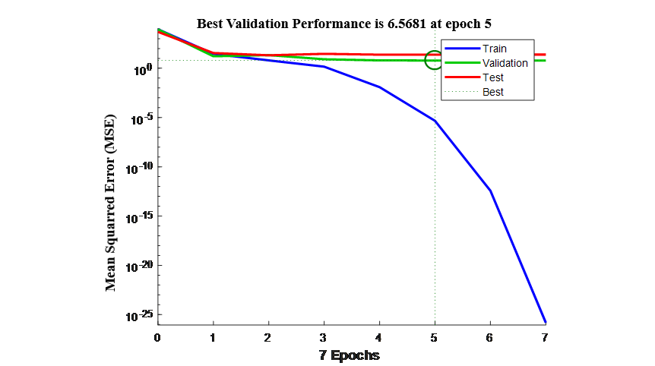

**Figure 4.3.2.1.2: Performance graph for experimental and predicted values of DTG-β-CD formulations prepared by physical mixing, kneading and solvent evaporation methods**

**Figure 4.3.2.1.3** illustrates the error histogram with 20 bins for DTG-β-CD formulations prepared by physical mixing, kneading and solvent evaporation methods of the trained neural network for the training, validation and testing steps indicated by blue, green and red bars.  In this, most errors fall between -0.2574 and 0, there is a training point with an error of 0.415 and validation points with errors of 2.432 and 4.449. Histogram plots provide additional verification of network performance. This figure shows that the data fitting errors are distributed within a reasonably good range around zero.



**Figure 4.3.2.1.3: Error histogram for experimental and predicted values of DTG-β-CD formulations prepared by physical mixing, kneading and solvent evaporation methods**

**Figure 4.3.2.1.4** shows the network performance achieved using regression data for experimental and predicted values of DTG-β-CD formulations prepared by the optimized kneading method. The regression plots display the network outputs with respect to predicted values for training, validation, and test sets. For a perfect fit, the data should fall along a 45 degree line, where the network outputs are equal to the targets. Here, the fit is reasonably good for all data sets, with R values in each case of 0.9202 or more.



**Figure 4.3.2.1.4: Regression data for experimental and predicted values of DTG-β-CD formulations**

**4.3.2.2 Experimental and predicted values for chosen outputs of DTG-β-CD-complexes with hydrophilic polymers prepared by optimized kneading method**

The inputs given for the experiment and ANN modelling are: X1 (DTG), X2 (β-CD) and X3(PVP K30), X4 (PEG 6000), X5 (SOLUPLUS). The predicted values are obtained using the designed (2 layered ANN with 25 nodes in hidden layer architecture) ANN model (**Figure 4.3.2.2.1**).

**Figure 4.3.2.2.1** below shows the neural network design (2-1-20-1architecture) for prediction of Y1 (% drug release).

Output layer with one output

One Hidden layer with 20 neurons

Input layer with 5 inputs

X3

(PVP K30)

X2(β-CD)

Y1 (% of drug release for 10 minute time interval)

Bias

1

2

24

25

X1(DTG)

X4

(PEG 6000)

X5

(SOLUPLUS))

**Figure 4.3.2.2.1: Neural network design (5-1-25-1architecture) for prediction of Y1 (% of drug release)**

**Table 4.3.2.2.1** & **4.3.2.2.2** illustrates the experimental and predicted values for the chosen output Y1 (% drug release) at different sampling time (10 min) for DTG-β-CD-PVP K30, DTG-β-CD-PEG 6000 and DTG-β-CD-soluplus complex systems prepared by optimized kneading method in 0.1 N HCl and pH 6.8 phosphate buffer. It was observed that ANN model with 5 inputs and 20 nodes in hidden layer exhibits the overall best performance and has a very good ability to predict the original parameters of the very good system, using the response features that were defined for the system. From the **Table 4.3.2.2.1 t**he mean squared error of prediction is always lower than 0.4347 and the standard deviation observed in testing is 0.1771 and from **Table 4.3.2.2.2 t**he mean squared error of prediction is always lower than 0.2114 and the standard deviation observed in testing is 0.0946.

**Table 4.3.2.2.1: Experimental and predicted values for the chosen output (Y1) at different intervals of time for DTG-β-CD-PVP K30, DTG-β-CD-PEG 6000 and DTG-β-CD-soluplus complex systems prepared by the optimized kneading method 0.1 N HCl**

|  |  |  |  |  |  |  |  |  |  |  |  |  |
| --- | --- | --- | --- | --- | --- | --- | --- | --- | --- | --- | --- | --- |
| Time  (min) | Code | **% DRUG RELEASE FOR TIME INTERVALS (min) (Y1)** | | | | | | | | | | |
| **F10** | **F11** | **F12** | **F13** | **F14** | **F15** | **F16** | **F17** | **F18** | **MSE** | **STD** |
| X1 | 1 | 1 | 1 | 1 | 1 | 1 | 1 | 1 | 1 |
| X2 | 1.5 | 1.5 | 1.5 | 1.5 | 1.5 | 1.5 | 1.5 | 1.5 | 1.5 |
| X3 | 1 | 1.5 | 2 | - | - | - | - | - | - |
| X4 | - | - | - | 1 | 1.5 | 2 | - | - | - |
| X5 | - | - | - | - | - | - | 1 | 1.5 | 2 |
| 10 | Exp | 45.18 | 42.94 | 44.06 | 37.92 | 39.76 | 38.89 | 49.70 | 48.58 | 51.73 | 0.4673 | 0.2315 |
| Pre | 45.69 | 43.23 | 44.46 | 38.71 | 40.73 | 39.77 | 50.67 | 49.43 | 52.44 |
| 20 | Exp | 61.85 | 50.30 | 59.82 | 47.78 | 50.72 | 53.64 | 56.85 | 58.75 | 61.38 | 0.4714 | 0.2755 |
| Pre | 62.03 | 50.66 | 60.80 | 48.55 | 51.42 | 54.00 | 57.53 | 59.62 | 61.51 |
| 30 | Exp | 73.59 | 71.65 | 74.81 | 59.54 | 64.94 | 69.48 | 71.05 | 76.19 | 80.71 | 0.5161 | 0.1164 |
| Pre | 73.94 | 71.81 | 75.29 | 60.49 | 65.43 | 70.42 | 71.76 | 76.80 | 81.49 |
| 40 | Exp | 81.04 | 83.80 | 89.34 | 75.63 | 72.57 | 74.14 | 78.24 | 87.31 | 85.18 | 0.3971 | 0.1054 |
| Pre | 81.22 | 84.18 | 90.27 | 76.19 | 72.82 | 74.55 | 79.06 | 88.04 | 85.69 |
| 50 | Exp | 92.60 | 91.66 | 93.26 | 86.21 | 81.12 | 85.86 | 89.21 | 93.02 | 94.01 | 0.3641 | 0.1680 |
| Pre | 92.86 | 91.82 | 93.58 | 86.83 | 81.23 | 86.44 | 90.13 | 93.34 | 94.42 |
| 60 | Exp | 94.38 | 95.44 | 96.27 | 91.05 | 89.72 | 92.63 | 96.33 | 95.42 | 97.41 | 0.3924 | 0.1657 |
| Pre | 94.81 | 95.98 | 96.89 | 91.59 | 90.69 | 92.89 | 96.96 | 95.96 | 98.05 |
| 65 | Exp | 98.09 | 100.05 | 99.39 | 98.34 | 98.87 | 97.03 | 98.45 | 99.68 | 100.26 | 0.0743 | 0.1011 |
| Pre | 98.49 | 100.35 | 99.65 | 98.87 | 99.01 | 97.65 | 98.12 | 99.33 | 100.64 |
| Overall MSE | | | 0.4347 | | | | | | | | | |
| Overall STD | | | 0.1771 | | | | | | | | | |

*Exp= Experimental

*Pre= Predicted

**Table 4.3.2.2.2: Experimental and predicted values for the chosen output (Y1) at different intervals of time for DTG-β-CD-PVP K30, DTG-β-CD-PEG 6000 and DTG-β-CD-soluplus complex systems prepared by the optimized kneading method pH 6.8 phosphate buffer**

|  |  |  |  |  |  |  |  |  |  |  |  |  |
| --- | --- | --- | --- | --- | --- | --- | --- | --- | --- | --- | --- | --- |
| Time  (min) | Code | **% DRUG RELEASE FOR TIME INTERVALS (min) (Y1)** | | | | | | | | | | |
| **F10** | **F11** | **F12** | **F13** | **F14** | **F15** | **F16** | **F17** | **F18** | **MSE** | **STD** |
| X1 | 1 | 1 | 1 | 1 | 1 | 1 | 1 | 1 | 1 |
| X2 | 1.5 | 1.5 | 1.5 | 1.5 | 1.5 | 1.5 | 1.5 | 1.5 | 1.5 |
| X3 | 1 | 1.5 | 2 | - | - | - | - | - | - |
| X4 | - | - | - | 1 | 1.5 | 2 | - | - | - |
| X5 | - | - | - | - | - | - | 1 | 1.5 | 2 |
| 10 | Exp | 42.71 | 39.42 | 41.17 | 35.99 | 36.41 | 37.67 | 46.11 | 45.82 | 48.27 | 0.5334 | 0.1674 |
| Pre | 42.98 | 40.36 | 41.39 | 36.58 | 37.05 | 38.43 | 46.72 | 46.40 | 49.09 |
| 20 | Exp | 58.03 | 47.77 | 56.75 | 45.06 | 47.25 | 51.92 | 53.19 | 55.55 | 58.24 | 0.5363 | 0.2502 |
| Pre | 58.61 | 48.54 | 57.42 | 45.62 | 47.97 | 52.11 | 53.50 | 56.10 | 59.06 |
| 30 | Exp | 70.89 | 68.21 | 71.49 | 57.61 | 62.81 | 67.08 | 68.21 | 73.72 | 77.06 | 0.4477 | 0.1735 |
| Pre | 71.69 | 69.03 | 71.63 | 58.37 | 63.09 | 67.78 | 69.03 | 74.09 | 77.79 |
| 40 | Exp | 79.15 | 80.16 | 87.19 | 73.34 | 70.04 | 72.95 | 75.91 | 87.69 | 84.91 | 0.4028 | 0.1209 |
| Pre | 80.06 | 80.67 | 87.90 | 73.67 | 70.51 | 73.24 | 76.50 | 88.45 | 85.40 |
| 50 | Exp | 89.69 | 88.27 | 90.64 | 84.23 | 79.15 | 83.03 | 86.30 | 92.33 | 91.00 | 0.5323 | 0.2520 |
| Pre | 90.65 | 89.09 | 91.33 | 84.65 | 80.06 | 83.36 | 86.93 | 92.56 | 89.78 |
| 60 | Exp | 91.54 | 90.97 | 92.31 | 87.19 | 83.28 | 86.66 | 89.61 | 94.04 | 93.46 | 0.4012 | 0.5412 |
| Pre | 91.69 | 91.76 | 92.54 | 87.90 | 83.60 | 87.32 | 90.57 | 94.48 | 93.80 |
| 70 | Exp | 93.55 | 92.70 | 94.11 | 89.09 | 87.46 | 90.72 | 95.44 | 95.23 | 96.80 | 0.1267 | 0.1927 |
| Pre | 93.90 | 92.97 | 94.52 | 89.99 | 88.20 | 91.51 | 95.98 | 95.75 | 97.48 |
| 80 | Exp | 95.84 | 96.59 | 96.00 | 96.86 | 94.19 | 93.85 | 98.79 | 100.03 | 100.07 | 0.0283 | 0.0104 |
| Pre | 96.42 | 97.24 | 96.97 | 97.54 | 94.60 | 94.23 | 99.66 | 100.29 | 100.56 |
| 90 | Exp | 99.07 | 100.23 | 100.42 | 98.00 | 100.19 | 100.13 | - | - | - | 0.0119 | 0.0216 |
| Pre | 99.16 | 100.55 | 100.02 | 98.23 | 100.35 | 100.01 | - | - | - |
| Overall MSE | | | 0.2114 | | | | | | | | | |
| Overall STD | | | 0.0946 | | | | | | | | | |

*Exp= Experimental

*Pre= Predicted

**Figure 4.3.2.2.2** shows the performance graph with 20 for experimental and predicted values of DTG-β-CD-PVP K30, DTG-β-CD-PEG 6000 and DTG-β-CD-soluplus complex systems formulations prepared by optimized kneading method. The best validation performance was 8.9126 observed at epoch 7 as shown in **Figure 4.3.2.2.2**. When all three curves are similarly formed, this means that the network responds similarly to learning data as well as to the validation and test data. The probability of overfitting is thus smaller but not excluded. The validation and the test curves do not indicate overfitting. The training curve diminishes more than the validation curve and this way, represents that, the performance of the trained network with learning data is better than the one with the data not involved in the learning process

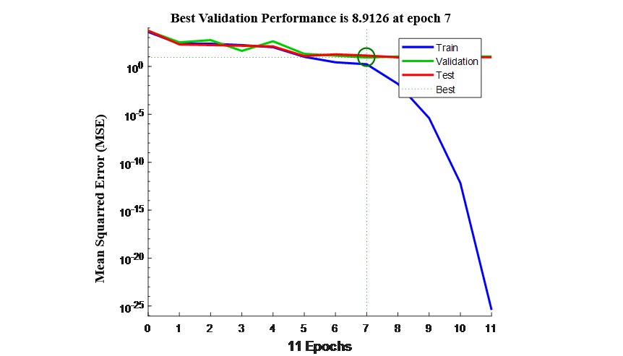

**Figure 4.3.2.2.2: Performance graph for experimental and predicted values of DTG-β-CD-PVP K30, DTG-β-CD-PEG 6000 and soluplus complex systems prepared by the optimized kneading method**

**Figure 4.3.2.2.3** illustrates the error histogram with 20 bins for DTG-β-CD with hydrophilic polymers formulations prepared by optimized kneading method of the trained neural network for the training, validation and testing steps indicated by blue, green and red bars.  In this, most errors fall between -2.5 and 2.24, there is a training point with an error of 1.726 and validation points with errors of -2.975 and 2.248. Histogram plots provide additional verification of network performance. This figure shows that the data fitting errors are distributed within a reasonably good range around zero.



**Figure 4.3.2.2.3: Error histogram for experimental and predicted values of DTG-β-CD-PVP K30, DTG-β-CD-PEG 6000 and DTG-β-CD-soluplus complex systems prepared by the optimized kneading method**

**Figure 4.3.2.2.4** shows the network performance using regression data for experimental and predicted values of DTG-β-CD-PVP K30, DTG-β-CD-PEG 6000 and DTG-β-CD-soluplus complex systems prepared by the optimized kneading method. The regression plots display the network outputs with respect to predicted values for training, validation, and test sets. For a perfect fit, the data should fall along a 45 degree line, where the network outputs are equal to the targets. Here, the fit is reasonably good for all data sets, with R values in each case being 0.99214 or more.



**Figure 4.3.2.2.4: Regression data of experimental and predicted values of DTG-β-CD-PVP K30, DTG-β-CD-PEG 6000 and DTG-β-CD-soluplus complex systems prepared by the optimized kneading method**

**4.3.2.3 Experimental and predicted values for chosen outputs of DTG and its various HP-β-CD -complexes without hydrophilic polymers**

The inputs given for the experiment and ANN modelling are: X1 (DTG), X2 (HP-β-CD). The predicted values are obtained using the designed (2 layered ANN with 25 nodes in hidden layer architecture) ANN mode (**Figure 4.3.2.3.1**).

**Figure 4.3.2.3.2** illustrates the performance (in terms of MSE and R) of the predicted values for DTG-HP-β-CD formulations prepared by physical mixing, kneading and solvent evaporation methods.

X2

(HP-β-CD)

X1 (DTG

Output layer with one output

One Hidden layer with 25 neurons

Input layer with 2 inputs

Y1 (% of drug release)

Bias

1

2

24

25

**Figure 4.3.2.3.1: Neural network design (2-1-25-1architecture) for prediction of Y1 (% of drug release)**

**Table 4.3.2.3.1** & **4.3.2.3.2** illustrates the experimental and predicted values for the chosen output Y1 (% drug release) at different sampling time (10 min) for DTG-HP-β-CD formulationsprepared by physical mixing, kneading and solvent evaporation methods in 0.1 N HCl and pH 6.8 phosphate buffer. It was observed that the ANN model with 5 inputs and 20 nodes in hidden layer exhibits the overall best performance. From **Table 4.3.2.3.1** the overall mean squared error of prediction is always lower than 0.2308 and the standard deviation observed are 0.0971 in testing and from **Table 4.3.2.3.2** the overall mean squared error of prediction is always lower than 0.2154 and the standard deviation observed are 0.1043 in testing. It represents the average squared error difference between actual output values and predicted values. **Table 4.3.2.3.1** & **4.3.2.3.2** shows the proposed method has a very good ability to predict the original parameters of the very good system, using the response features that were defined for the system.

**Table 4.3.2.3.1: Experimental and predicted values for the chosen output (Y1) at different intervals of time for DTG-HP-β-CD formulations prepared by physical mixing, kneading and solvent evaporation methods in 0.1 N HCl**

|  |  |  |  |  |  |  |  |  |  |  |  |  |
| --- | --- | --- | --- | --- | --- | --- | --- | --- | --- | --- | --- | --- |
| Time  (min) | Code | **% DRUG RELEASE FOR TIME INTERVALS (min) (Y1)** | | | | | | | | | | |
| **F19** | **F20** | **F21** | **F22** | **F23** | **F24** | **F25** | **F26** | **F27** | **MSE** | **STD** |
| X1 | 1 | 1 | 1 | 1 | 1 | 1 | 1 | 1 | 1 |
| X2 | 1 | 1.5 | 2 | 1 | 1.5 | 2 | 1 | 1.5 | 2 |
| 10 | Exp | 23.28 | 24.44 | 26.86 | 36.34 | 38.24 | 39.35 | 35.73 | 38.86 | 34.44 | 0.7941 | 0.2279 |
| Pre | 23.60 | 24.88 | 27.54 | 36.97 | 39.06 | 40.28 | 36.30 | 39.74 | 34.88 |
| 20 | Exp | 38.24 | 35.56 | 36.43 | 48.52 | 50.07 | 49.19 | 46.66 | 51.41 | 48.47 | 0.5331 | 0.1089 |
| Pre | 39.06 | 36.11 | 37.07 | 49.37 | 50.75 | 50.10 | 47.32 | 51.55 | 49.31 |
| 30 | Exp | 46.88 | 42.72 | 49.75 | 63.27 | 65.18 | 58.30 | 62.07 | 62.18 | 65.66 | 0.6402 | 0.1412 |
| Pre | 47.56 | 42.99 | 50.72 | 63.59 | 65.69 | 59.13 | 62.33 | 62.99 | 66.22 |
| 40 | Exp | 58.12 | 56.09 | 58.07 | 77.47 | 74.19 | 70.98 | 75.69 | 73.07 | 74.67 | 0.5449 | 0.1101 |
| Pre | 58.93 | 56.78 | 58.94 | 78.21 | 74.60 | 71.96 | 76.25 | 73.44 | 75.13 |
| 50 | Exp | 69.33 | 74.45 | 79.62 | 87.82 | 86.81 | 81.36 | 80.68 | 86.28 | 86.54 | 0.4940 | 0.1066 |
| Pre | 70.26 | 74.89 | 80.58 | 88.60 | 87.49 | 81.67 | 81.36 | 86.90 | 87.19 |
| 60 | Exp | 84.19 | 85.28 | 87.16 | 90.70 | 91.24 | 92.97 | 90.47 | 92.11 | 91.84 | 0.3684 | 0.1443 |
| Pre | 84.60 | 85.80 | 87.87 | 91.20 | 91.65 | 93.26 | 91.21 | 92.32 | 92.65 |
| 70 | Exp | 94.38 | 93.89 | 99.57 | 95.36 | 97.14 | 100.31 | 98.99 | 99.25 | 96.59 | 0.3462 | 0.1311 |
| Pre | 94.81 | 94.27 | 99.83 | 95.89 | 97.55 | 100.61 | 99.23 | 99.67 | 96.88 |
| 75 | Exp | 99.09 | 98.01 | - | 99.98 | 100.92 | - | - | - | 100.44 | 0.2610 | 0.1354 |
| Pre | 99.54 | 98.90 | - | 99.64 | 100.25 | - | - | - | 100.87 |
| Overall MSE | | | 0.2308 | | | | | | | | | |
| Overall STD | | | 0.0971 | | | | | | | | | |

*Exp= Experimental

*Pre= Predicted

**Table 4.3.2.3.2: Experimental and predicted values for the chosen output (Y1) at different intervals of time for DTG-HP-β-CD formulations prepared by physical mixing, kneading and solvent evaporation methods in pH 6.8 phosphate buffer**

|  |  |  |  |  |  |  |  |  |  |  |  |  |
| --- | --- | --- | --- | --- | --- | --- | --- | --- | --- | --- | --- | --- |
| Time  (min) | Code | **% DRUG RELEASE FOR TIME INTERVALS (min) (Y1)** | | | | | | | | | | |
| **F19** | **F20** | **F21** | **F22** | **F23** | **F24** | **F25** | **F26** | **F27** | **MSE** | **STD** |
| X1 | 1 | 1 | 1 | 1 | 1 | 1 | 1 | 1 | 1 |
| X2 | 1 | 1.5 | 2 | 1 | 1.5 | 2 | 1 | 1.5 | 2 |
| 10 | Exp | 11.79 | 13.15 | 11.06 | 16.97 | 17.91 | 18.24 | 18.01 | 16.72 | 18.95 | 0.6255 | 0.2022 |
| Pre | 10.98 | 12.84 | 11.67 | 17.66 | 18.70 | 19.06 | 18.82 | 17.39 | 19.84 |
| 20 | Exp | 17.54 | 18.33 | 16.62 | 22.72 | 23.35 | 24.18 | 23.67 | 25.22 | 21.83 | 0.5264 | 0.1173 |
| Pre | 18.29 | 19.16 | 17.28 | 22.99 | 23.70 | 21.29 | 24.04 | 25.74 | 22.01 |
| 30 | Exp | 28.16 | 27.86 | 28.91 | 34.47 | 33.72 | 35.63 | 31.38 | 34.12 | 33.08 | 0.4312 | 0.1553 |
| Pre | 28.97 | 28.64 | 29.80 | 34.91 | 34.09 | 35.99 | 31.69 | 34.53 | 33.46 |
| 40 | Exp | 31.78 | 35.39 | 37.04 | 41.32 | 39.53 | 42.73 | 39.44 | 41.36 | 40.13 | 0.5528 | 0.2024 |
| Pre | 32.49 | 35.92 | 37.51 | 41.63 | 40.48 | 43.00 | 40.38 | 41.49 | 40.44 |
| 50 | Exp | 48.45 | 47.97 | 46.59 | 51.83 | 45.53 | 50.28 | 46.51 | 50.24 | 49.62 | 0.4854 | 0.1112 |
| Pre | 48.93 | 48.76 | 47.24 | 52.01 | 46.09 | 50.53 | 47.16 | 50.76 | 50.58 |
| 60 | Exp | 52.24 | 53.32 | 50.06 | 55.01 | 58.28 | 56.91 | 57.34 | 55.33 | 54.01 | 0.1814 | 0.2301 |
| Pre | 52.46 | 53.65 | 50.54 | 55.62 | 59.10 | 57.60 | 58.07 | 55.86 | 54.46 |
| 80 | Exp | 75.08 | 69.99 | 65.28 | 82.04 | 79.28 | 71.17 | 78.21 | 70.51 | 65.14 | 0.1917 | 0.1242 |
| Pre | 75.29 | 70.98 | 65.80 | 82.32 | 80.20 | 71.48 | 79.03 | 71.08 | 65.65 |
| 90 | Exp | 83.16 | 84.21 | 79.32 | 99.09 | 100.01 | 85.01 | 98.01 | 85.46 | 82.37 | 0.3108 | 0.1462 |
| Pre | 83.47 | 84.63 | 80.25 | 99.34 | 100.36 | 85.58 | 98.90 | 86.00 | 82.60 |
| 100 | Exp | 99.84 | 100.73 | 100.48 | - | - | 100.92 | - | 99.62 | 100.36 | 0.1256 | 0.0953 |
| Pre | 100.28 | 100.23 | 100.04 |  |  | 99.86 |  | 99.88 | 100.64 |
| Overall MSE | | | 0.2154 | | | | | | | | | |
| Overall STD | | | 0.1043 | | | | | | | | | |

*Exp= Experimental

*Pre= Predicted

**Figure 4.3.2.3.2** shows the performance graph for experimental and predicted values of DTG-HP-β-CDformulations prepared by physical mixing, kneading and solvent evaporation methods. The best validation performance was 23.8673 observed at epoch 8 as indicated in **Figure 4.3.2.3.2**. When all three curves are similarly formed, this means that the network responds similarly to learning data as well as to the validation and test data. The probability of overfitting is thus smaller but not excluded. The validation and the test curves do not indicate overfitting. The training curve diminishes more than the validation curve and this way, represents that, the performance of the trained network with learning data is better than with the data not involved in the learning process.

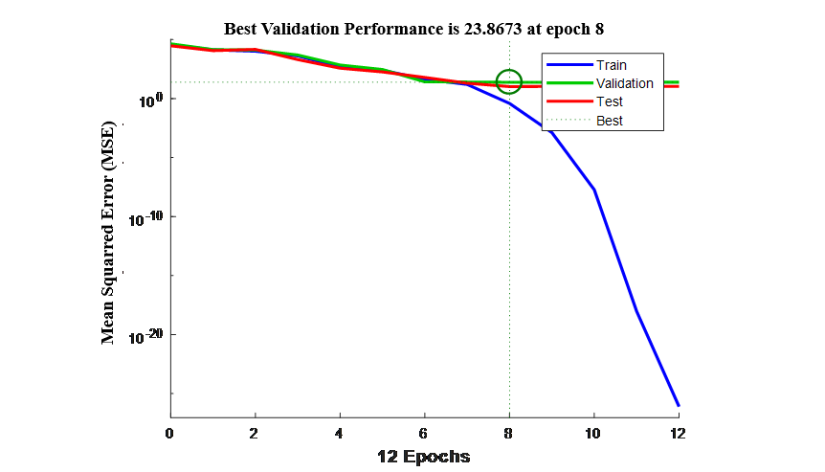

**Figure 4.3.2.3.2: Performance graph for experimental and predicted values of DTG-HP-β-CD formulations prepared by physical mixing, kneading and solvent evaporation methods**

**Figure 4.3.2.3.3** illustrates the error histogram with 20 bins for DTG-HP-β-CD formulations prepared by physical mixing, kneading and solvent evaporation methods of the trained neural network for the training, validation and testing steps indicated by blue, green and red bars.  In this, most errors fall between -2.761 and 2.412, there is a training point with an error of -1.861 and validation points with errors of 4.121 and 4.976. Histogram plots provide additional verification of network performance. This figure shows that the data fitting errors are distributed within a reasonably good range around zero.



**Figure 4.3.2.3.3: Error histogram for experimental and predicted values of DTG-HP-β-CD formulations prepared by physical mixing, kneading and solvent evaporation methods**

**Figure 4.3.2.3.4** shows the network performance using regression data for experimental and predicted values of DTG-HP-β-CD formulations prepared by the physical mixing, kneading and solvent evaporation methods. The regression plots display the network outputs with respect to predicted values for training, validation, and test sets. For a perfect fit, the data should fall along a 45 degree line, where the network outputs are equal to the targets. Here, the fit is reasonably good for all data sets, with R values in each case being 0.98609 or more.



**Figure 4.3.2.3.4: Regression data for experimental and predicted values of DTG-HP-β-CD formulations prepared by physical mixing, kneading and solvent evaporation methods**

**4.3.2.4. Experimental and predicted values for chosen outputs of DTG and its various HP-β-CD -complexes with hydrophilic polymers**

The inputs given for the experiment and ANN modelling are: X1 (DTG), X2 (HP-β-CD) and X3(PVP K30), X4(PEG 6000), X5(SOLUPLUS). The predicted values are obtained using the designed (2 layered ANN with 20 nodes in hidden layer architecture) ANN mode (**Figure 4.3.2.4.1**).

Output layer with one output

One Hidden layer with 20 neurons

Input layer with 5 inputs

X3

(PVP K30)

X2(HP-β-CD)

Y1 (% of drug release for 10 minute time interval)

Bias

1

2

19

20

X1(DTG),

X4

(PEG 6000)

X5

(SOLUPLUS)

**Figure 4.3.2.4.1: Neural network design (5-1-20-1architecture) for prediction of Y1 (% of drug release)**

**Table 4.3.2.4.1** & **4.3.2.4.2** illustrates the experimental and predicted values for the chosen output Y1 (% drug release) at different sampling time (10 min) for DTG-HP-β-CD-PVP K30, DTG-HP-β-CD-PEG 6000 and DTG-HP-β-CD-soluplus complex systems prepared by optimized kneading method in 0.1 N HCl and pH 6.8 phosphate buffer. It was observed that the ANN model with 5 inputs and 20 nodes in hidden layer exhibits the overall best performance. From the **Table 4.3.2.4.1** the mean error of prediction is always lower than 0.4285 and the standard deviation observed are 0.1502 in testing and from the **Table 4.3.2.4.2** the mean error of prediction is always lower than 0.5708 and the standard deviation observed are 0.2705 in testing. **Table 4.3.2.4.1** & **4.3.2.4.2** illustrates that the proposed method has a very good ability to predict the original parameters of the very good system, using the response features that were defined for the system.

**Table 4.3.2.4.1: Experimental and predicted values for the chosen output (Y1) at different intervals of time for DTG-HP-β-CD-PVP K30, DTG-HP-β-CD-PEG 6000 and DTG-HP-β-CD-soluplus complex systems prepared by the optimized kneading method 0.1 N HCl**

|  |  |  |  |  |  |  |  |  |  |  |  |  |
| --- | --- | --- | --- | --- | --- | --- | --- | --- | --- | --- | --- | --- |
| Time  (min) | Code | **% DRUG RELEASE FOR TIME INTERVALS (min) (Y1)** | | | | | | | | | | |
| **F28** | **F29** | **F30** | **F31** | **F32** | **F33** | **F34** | **F35** | **F36** | **MSE** | **STD** |
| X1 | 1 | 1 | 1 | 1 | 1 | 1 | 1 | 1 | 1 |
| X2 | 2 | 2 | 2 | 2 | 2 | 2 | 2 | 2 | 2 |
| X3 | 1 | 1.5 | 2 | - | - | - | - | - | - |
| X4 | - | - | - | 1 | 1.5 | 2 | - | - | - |
| X5 | - | - | - | - | - | - | 1 | 1.5 | 2 |
| 10 | Exp | 56.16 | 53.36 | 55.52 | 51.65 | 52.88 | 53.92 | 60.99 | 62.08 | 59.02 | 0.2372 | 0.1073 |
| Pre | 56.67 | 53.72 | 56.07 | 51.81 | 53.16 | 54.31 | 61.89 | 62.79 | 59.73 |
| 20 | Exp | 71.30 | 65.43 | 69.60 | 59.70 | 61.80 | 63.85 | 77.54 | 79.51 | 75.82 | 0.0851 | 0.1798 |
| Pre | 71.61 | 65.97 | 70.56 | 60.49 | 62.61 | 64.68 | 78.29 | 80.46 | 76.40 |
| 30 | Exp | 75.89 | 72.95 | 81.10 | 64.28 | 66.45 | 74.59 | 89.82 | 92.89 | 88.95 | 0.2049 | 0.2301 |
| Pre | 76.47 | 73.24 | 81.41 | 64.70 | 67.09 | 75.04 | 90.17 | 93.17 | 89.84 |
| 40 | Exp | 87.12 | 81.31 | 88.48 | 73.66 | 74.38 | 84.90 | 93.96 | 95.14 | 91.33 | 0.5312 | 0.1729 |
| Pre | 87.83 | 81.06 | 89.32 | 74.02 | 74.81 | 85.39 | 94.32 | 95.65 | 91.64 |
| 50 | Exp | 94.50 | 90.61 | 93.85 | 87.39 | 84.49 | 95.79 | 96.55 | 97.89 | 95.99 | 0.1776 | 0.1254 |
| Pre | 94.95 | 90.77 | 94.43 | 88.12 | 84.93 | 96.36 | 97.20 | 98.00 | 96.32 |
| 60 | Exp | 97.38 | 98.53 | 99.01 | 98.50 | 99.22 | 99.29 | 98.98 | 100.45 | 99.73 | 0.1794 | 0.2621 |
| Pre | 98.11 | 98.66 | 99.42 | 98.87 | 99.45 | 99.58 | 99.12 | 100.88 | 99.92 |
| Overall MSE | | | 0.4285 | | | | | | | | | |
| Overall STD | | | 0.1502 | | | | | | | | | |

*Exp= Experimental

*Pre= Predicted

**Table 4.3.2.4.2: Experimental and predicted values for the chosen output (Y1) at different intervals of time for DTG-HP-β-CD-PVP K30, DTG-HP-β-CD-PEG 6000 and DTG-HP-β-CD-soluplus complex systems prepared by the optimized kneading method pH 6.8 phosphate buffer**

|  |  |  |  |  |  |  |  |  |  |  |  |  |
| --- | --- | --- | --- | --- | --- | --- | --- | --- | --- | --- | --- | --- |
| Time  (min) | Code | **% DRUG RELEASE FOR TIME INTERVALS (min) (Y1)** | | | | | | | | | | |
| **F28** | **F29** | **F30** | **F31** | **F32** | **F33** | **F34** | **F35** | **F36** | **MSE** | **STD** |
| X1 | 1 | 1 | 1 | 1 | 1 | 1 | 1 | 1 | 1 |
| X2 | 2 | 2 | 2 | 2 | 2 | 2 | 2 | 2 | 2 |
| X3 | 1 | 1.5 | 2 | - | - | - | - | - | - |
| X4 | - | - | - | 1 | 1.5 | 2 | - | - | - |
| X5 | - | - | - | - | - | - | 1 | 1.5 | 2 |
| 10 | Exp | 54.33 | 51.92 | 53.50 | 48.72 | 49.75 | 50.07 | 56.08 | 58.24 | 55.42 | 0.3141 | 0.1412 |
| Pre | 54.96 | 52.54 | 54.20 | 49.43 | 50.38 | 50.73 | 56.84 | 58.98 | 56.30 |
| 20 | Exp | 69.09 | 63.22 | 67.38 | 56.71 | 58.82 | 60.08 | 73.25 | 76.67 | 71.49 | 0.1303 | 0.2026 |
| Pre | 69.72 | 63.75 | 68.11 | 57.24 | 59.38 | 61.00 | 73.99 | 77.17 | 72.43 |
| 30 | Exp | 73.28 | 70.95 | 79.03 | 61.35 | 63.67 | 71.87 | 87.19 | 89.36 | 85.16 | 0.1524 | 0.1510 |
| Pre | 74.11 | 71.54 | 79.42 | 61.88 | 64.33 | 72.65 | 87.90 | 89.99 | 85.67 |
| 40 | Exp | 85.91 | 79.51 | 86.53 | 70.40 | 72.59 | 80.71 | 89.27 | 91.84 | 87.81 | 0.2543 | 0.1954 |
| Pre | 86.50 | 80.10 | 86.18 | 70.63 | 73.18 | 80.45 | 89.54 | 92.32 | 87.36 |
| 50 | Exp | 92.43 | 88.57 | 91.10 | 84.23 | 82.28 | 86.23 | 91.80 | 94.32 | 95.73 | 0.2063 | 0.1323 |
| Pre | 92.03 | 89.42 | 91.62 | 84.72 | 82.50 | 86.85 | 91.26 | 94.75 | 96.30 |
| 60 | Exp | 93.61 | 92.71 | 93.55 | 86.84 | 88.16 | 90.52 | 94.51 | 96.30 | 97.29 | 0.2842 | 0.2441 |
| Pre | 93.97 | 92.98 | 93.90 | 86.52 | 88.97 | 90.97 | 94.96 | 96.93 | 98.01 |
| 70 | Exp | 95.43 | 96.03 | 96.70 | 93.96 | 95.97 | 97.87 | 96.07 | 100.45 | 99.45 | 0.1245 | 0.1443 |
| Pre | 95.97 | 96.72 | 97.37 | 94.35 | 96.56 | 98.23 | 96.54 | 100.78 | 99.79 |
| 80 | Exp | 98.97 | 99.49 | 99.87 | 99.59 | 98.99 | 99.15 | 99.77 | - | - | 0.2437 | 0.0996 |
| Pre | 98.01 | 99.09 | 100.02 | 98.96 | 97.98 | 99.65 | 99.23 | - | - |
| Overall MSE | | | 0.5708 | | | | | | | | | |
| Overall STD | | | 0.2705 | | | | | | | | | |

*Exp= Experimental

*Pre= Predicted

**Figure 4.3.2.4.2** shows the performance graph with 20 hidden nodes for experimental and predicted values of DTG-HP-β-CD-PVP K30, DTG-HP-β-CD-PEG 6000 and DTG-HP-β-CD-soluplus complex systemformulations prepared by optimized kneading method. The best validation performance was 18.0493 observed at epoch 10 as indicated in **Figure 4.3.2.4.2** out of 14 epochs. When all three curves are similarly formed, this means that the network responds similarly to learning data as well as to the validation and test data. The probability of overfitting is thus smaller but not excluded. This performance plot shows no noticeable problems. The validation and the test curves do not indicate overfitting. The training curve diminishes more than the validation curve and this way, indicates that, the performance of the trained network with learning data is better than the one with the data not involved in the learning process.

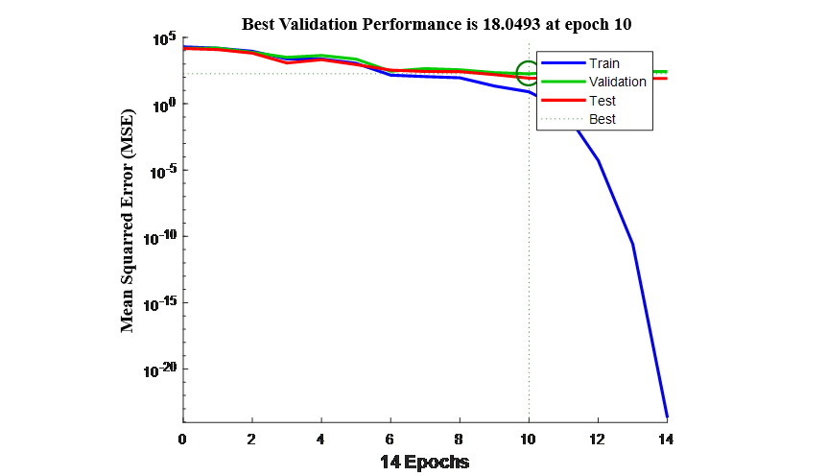

**Figure 4.3.2.4.2: Performance graph for experimental and predicted values of DTG-HP-β-CD-PVP K30, DTG-HP-β-CD-PEG 6000 and DTG-HP-β-CD-soluplus complex systems prepared by the optimized kneading method**

**Figure 4.3.2.4.3** illustrates the error histogram with 20 bins for DTG-HP-β-CD formulations prepared by optimized kneading method of the trained neural network for the training, validation and testing steps indicated by blue, green and red bars.  In this, most errors fall between -7.549 and 4.986, there is a training point with an error of -1.861 and validation points with errors of 17.52 and 20.65. Histogram plots provide additional verification of network performance. This figure shows that the data fitting errors are distributed within a reasonably good range around zero.



**Figure 4.3.2.4.3: Error histogram for experimental and predicted values of DTG-HP-β-CD-PVP K30, DTG-HP-β-CD-PEG 6000 and DTG-HP-β-CD- soluplus complex systems prepared by the optimized kneading method**

**Figure 4.3.2.4.4** shows the Regression data for experimental and predicted values of DTG-HP-β-CD-PVP K30, DTG-HP-β-CD-PEG 6000 and DTG-HP-β-CD-soluplus complex systems prepared by the optimized kneading method. This is used to validate the network performance. The regression plots display the network outputs with respect to targets for training, validation, and test sets. For a perfect fit, the data should fall along a 45 degree line, where the network outputs are equal to the targets. Here, the fit is reasonably good for all data sets, with R values in each case being 0.9630 or more.



**Figure 4.3.2.4.4: Regression data for experimental and predicted values of DTG-HP-β-CD-PVP K30, DTG-HP-β-CD-PEG 6000 and DTG-HP-β-CD-soluplus complex systems prepared by the optimized kneading method**

**4.4. DISCUSSION**

Two layered Levenberg-Marquardt ANN was used for the predicted values. Predicted ANN responses of CBS formulations C1 to C36 and DTG formulations F1 to F36 indicated no significant difference between predicted and the experimental responses. Overall network performance was evaluated and shown in their respective performance graphs where the best validation performance, error histograms where the data fitting the errors are within the reasonable good range was observed.

* 1. **CONCLUSION**

ANN programs have been widely used to develop pharmaceutical formulations. The application of ANN was used in reaching the optimum point with corrected value in the shortest time period. ANN are characterized essentially by their abilities to learn and to generalize, their robustness against disorder and lack of data, their fault tolerance and their high performance based on parallel processing. During the training period the network learns the present learning examples by adapting their parameter (connection weights and bias) to the examples. The network performance was validated by the regression data which validates the network output with respect to training, validation and test sets and a good fit shows the network outputs are almost equal to targets with minimum error.

**REFERENCES**

1. Vijaykumar S, Anastasia G, Prabodh S, Deepak B and Yashwant P. Artificial neural network in drug delivery and pharmaceutical research, The Open Bioinformatics Journal, 2013; 7(1): 49-62.
2. Ibric S, Djuric Z, Parojcic J and Petrovic J. Artificial intelligence in pharmaceutical product formulation: neural computing, Chemical Industry & Chemical Engineering Quarterly, 2009; 15 (4): 227−236.
3. Minovski N, Zuperl S, Drgan V and Novic M. Assessment of applicability domain for multivariate counter-propagation artificial neural network predictive models by minimum euclidean distance space analysis: a case study, Analytical Chimica Acta, 2013; 759: 28-42.
4. Bartzatt R. Anti-inflammatory drugs and prediction of new structures by comparative analysis, Anti-inflammatory and Anti-allergy Agents in Medicinal Chemistry, 2012; 11(2): 151-60.
5. Turkoglu M, Ozarslan R and Sakr A. Artificial neural network analysis of a direct compression tabletting study, European Journal of Pharmaceutics and Biopharmaceutics, 1995; 41(5): 315-322.
6. Kesavan J G and Peck G E. Pharmaceutical granulation and tablet formulation using neural network, Pharmaceutical Development and Technology, 1996; 1(4): 391-404.
7. Rocksloh K, Rapp F R, Abu Abed S, Mueller W, Reher M, Gauglitz G and Schmidt P C. Optimization of crushing strength and disintegration time of a high-dose plant extract tablet by neural networks, Drug Devlopment and Industrial Pharmacy, 1999; 25(2): 1015-1025.
8. Chen U, Thosor S, Forbess R, Kemper M, Rubinovitz R L and Shukla A J. Prediction of drug content and hardness of intact tablets using artificial neural network and near infrared spectroscopy, Drug Development and Industrial Pharmacy, 2001; 27: 623-631.

# Pradeep M S and Jurgen V. Comparison of neural network and multiple linear regression as dissolution predictors, Drug Development and Industrial Pharmacy, 2003; 29(3): 349-355.

1. Damjana Z B, Vrecar and Kozjek F. Optimization of diclofenac sodium sustained release matrix tablets using artificial neural network. European Journal of Pharmaceutical Sciences, 1997; 5: 163-170.
2. Takayama K, Morva A, Fujikawa M, Hattori Y, Obata Y and Nagai T. Formula optimization of theophylline controlled-release tablet based on artificial neural networks, Journal of Controlled Release, 2000; 68(2): 175-186.

# Ibrić S, Jovanović M, Đurić Z, Parojčić J, Patrovic S D and Solomun B. Lučić. Artificial neural networks in evaluation and optimization of modified release solid dosage forms, Journal of Pharmacy and Pharmacology, 2003; 4: 62-70.

1. Ibrić S, Jovanović M, Đurić Z, Parojčić J, Solomun L and Lučić B. Generalised regression neural networks in predicting of drug stability, Journal of Pharmacy and Pharmacology, 2007; 59 (5): 745–750.
2. Wu T, Pao W, Chen J and Shang R. Formulation optimization technique based on artificial neural network in salbutamol sulphate osmotic pump tablets, Drug Development and Industrial Pharmacy, 2000; 26(2): 211-215.
3. Peh K K, Chee Peng L, Sion San Q and Kean H K. Use of artificial networks to predict drug dissolution profiles and evaluation of network performance using similarity profile, Pharmaceutical Research, 2000; 17(11): 1386-1398.
4. Sion San Q, Chee Peng Lim and Peh K K. Application of both multi-layer perceptrons and recurrent neural networks to modelling the release of theophylline from a matrix controlled release pellet formulation prepared using extrusion and spheronization, International Journal of Computers and Applications, 2001; 1: 187-292
5. Vaithiyalingam S and Mansoor A Khan. Optimization and characterization of controlled release multi particulate beads formulated with a customized cellulose acetate butyrate dispersion, International Journal of Pharmaceutics, 2002; 234(1-2):179-193.
6. Turkoglu M, Varol H and Celikok M. [Tableting and stability evaluation of enteric-coated omeprazole pellets](javascript:void(0)), European Journal of Pharmaceutics and Biopharmaceutics, 2004; 57(2): 277-286.
7. Tejas B P, Tushar R P and Bhanubhai N S. Artificial neural network as tool for quality by design in formulation development of solid dispersion of fenofibrate, Bulletin of Pharmaceutical Research 2015;5(1): 20-27.
8. Prithviraj C, Versha P, Debarupa C and Amitava G. Application of artificial neural network model in predicting physicochemical characteristics of pharmaceutically developed wafers of loratadine, Asian Journal of Pharmaceutics, 2015; 9(1): 45-47.
9. Buket A, Gizem Y, Sevim P, Erdal C and Yıldız. Optimisation of ondansetron orally disintegrating tablets using artificial neural networks, Tropical Journal of Pharmaceutical Research September, 2014; 13 (9): 1374-1383.
10. Wen- Jin X, Ning L and Chong kai G. Preparation of controlled porosity osmotic pump tablets for salvolonic acid and optimization of the formulation using an artificial neural networks, Acta Pharmaceutica Sinica B, 2011; 1(1): 64-70.
11. Aleksander M, Renata J and Przemyslaw D. Artificial neural networks in the modeling of drugs release profiles from hydrodynamically balanced systems, Acta Poloniae Pharmaceutica in Drug Research, 2006; 63(1): 75-80.